**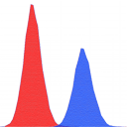MZmine 2 manual**

**About MZmine 2**

Copyright (c) 2005-2010 MZmine Development Team

MZmine 2 is an open-source framework for processing, visualization and analysis of mass spectrometry based molecular profile data. It is based on the original MZmine toolbox described in 2006 Bioinformatics publication.

**License**

This program is free software; you can redistribute it and/or modify it under the terms of the GNU General Public License as published by the Free Software Foundation; either version 2 of the License, or (at your option) any later version.

This program is distributed in the hope that it will be useful, but WITHOUT ANY WARRANTY; without even the implied warranty of MERCHANTABILITY or FITNESS FOR A PARTICULAR PURPOSE. See the GNU General Public License for more details.

You should have received a copy of the GNU General Public License along with this program; if not, write to the Free Software Foundation, Inc., 51 Franklin Street, Fifth Floor, Boston, MA 02110-1301, USA.

**Table of contents**

1. Usage and workflow 5

1.1. Starting MZmine 2 5

1.2. MZmine 2 desktop 5

1.3. Number and time formatting 6

1.3.1. Number formatting 6

1.3.2. Time formatting 6

1.4. Data processing workflow 6

1.5. Batch mode 7

2. Raw data file import 8

2.1. Supported file formats 8

2.1.1. Thermo RAW support 8

3. Raw data filtering 9

3.1. Dataset filters 9

3.1.1. Crop filter 9

3.2. Scan filters 10

3.2.1. Mean filter 10

3.2.2. Savitzky Golay filter 10

3.2.3. Crop filter 11

3.2.4. m/z resample filter 11

4. Peak detection 13

4.1. Chromatogram builder 13

4.1.1. Mass detection 13

4.1.2. Centroid mass detector 13

4.1.3. Exact mass detector 14

4.1.4. Local maxima mass detector 15

4.1.5. Recursive threshold mass detector 16

4.1.6. Wavelet transform mass detector 16

4.1.7. Filtering 19

4.1.8. FTMS shoulder peaks filter 19

4.1.9. Chromatogram construction 22

4.1.10. Highest data point 22

4.2. MS/MS peak picker 23

4.3. Chromatogram deconvolution 24

4.3.1. Baseline cut-off 24

4.3.2. Noise amplitude 25

4.3.3. Savitzky-Golay 26

4.3.4. Local minimum search 27

4.4. Peak extender 28

4.5. Peak shape modeler 30

5. Isotope patterns 32

5.1. Isotopic peaks grouper 32

5.2. Isotope pattern checking 33

5.3. Isotope pattern prediction 34

5.4. Isotope pattern comparison 35

6. Gap filling 36

6.1. Peak finder 36

6.2. Same m/z and RT range gap filler 38

7. Peak list alignment 39

7.1. Join aligner 39

7.2. RANSAC aligner 41

8. Normalization 45

8.1. Linear normalizer 45

8.1.1. Normalization factors 45

8.2. Retention time normalizer 46

8.3. Standard compound normalizer 47

9. Identification 49

9.1. Adduct Search 49

9.2. Peak complex search 51

9.3. Custom database search 52

9.4. Online database search 53

9.4.1. Supported databases 55

9.5. Fragment search 56

9.6. Glycerophospholipid prediction 57

9.7. Mascot search 58

10. Peak list filtering 59

10.1. Duplicate filter 59

10.2. Rows filter 59

11. Data analysis 61

11.1. Projection plots 61

11.1.1. Principal component analysis (PCA) 61

11.1.2. Sammon's projection 62

11.1.3. Curvilinear distance analysis (CDA) 62

11.2. CV and Logratio analysis 64

11.2.1. Coefficient of variation (CV) 64

11.2.2. Logratio analysis 64

12. Peak list export and import 66

12.1. CSV export 66

12.2. XML export and import 66

13. Project saving and loading 69

13.1. Project file format 69

14. Visualization 72

14.1. TIC/XIC visualizer 72

14.2. Spectra plot 76

14.3. 2D visualizer 82

14.4. 3D visualizer 88

14.5. Peak list table 93

14.6. Scatter plot 97

14.7. Histogram plot 101

14.8. Intensity plot 102

14.9. Neutral loss visualizer 104

# Usage and workflow

## Starting MZmine 2

MZmine 2 can run on any platform which has a Java runtime available (version 1.6 or higher). A startup script is provided for MS Windows (*startMZmine\_Windows.bat*), Mac OS X (*startMZmine\_MacOSX.command*) and Linux (*startMZmine\_Linux.sh*) environments. The startup script may be edited to tweak various Java runtime parameters. Particularly, the amount of memory allocated for the Java Virtual Machine may be adjusted by editing the HEAP\_SIZE parameter in the startup script. Default value is set to 1GB. If your computer has more RAM available and you wish to use it for MZmine 2, please edit the startup script.

## MZmine 2 desktop

The following screenshot describes the main components of the MZmine 2 desktop:

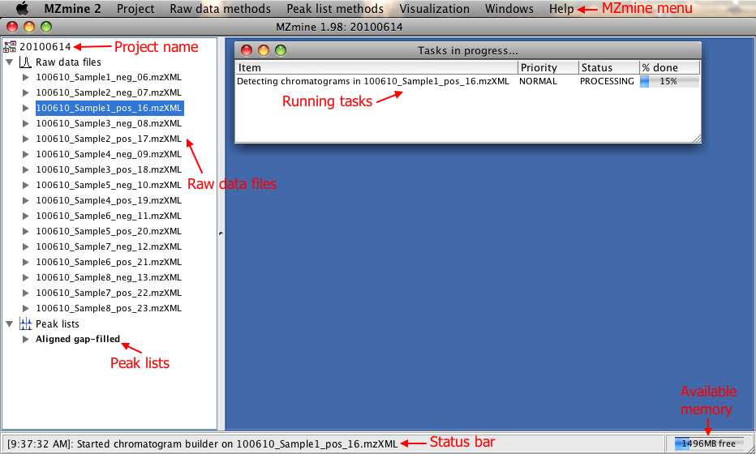

## Number and time formatting

Formatting of the m/z, retention time and intensity values may be modified in the dialog activated by the Project / Set number formats menu item. The following symbols are used in the number and time formatting patterns.

### Number formatting

0 = Digit  
# = Digit (zero absent)  
. = Decimal separator  
, = Grouping separator  
E = Exponent   
% = Percentage

### Time formatting

H = Hour  
m = Minute  
s = Second  
S = Millisecond

## Data processing workflow

A typical workflow for processing mass spectrometry data using MZmine 2 consists of the following steps (note that some of these steps are optional and may be skipped):

1. [Raw data import](file://localhost/net/sf/mzmine/modules/rawdatamethods/rawdataimport/help/RawDataImporter.html)
2. Detection of chromatograms using the [Chromatogram builder](file://localhost/net/sf/mzmine/modules/rawdatamethods/peakpicking/chromatogrambuilder/help/ChromatogramBuilder.html)
3. [Deconvolution](file://localhost/net/sf/mzmine/modules/peaklistmethods/peakpicking/deconvolution/help/Deconvolution.html) of chromatograms into individual peaks
4. [Deisotoping](file://localhost/net/sf/mzmine/modules/peaklistmethods/isotopes/deisotoper/help/IsotopeGrouper.html)
5. Identification of [frgments](file://localhost/net/sf/mzmine/modules/peaklistmethods/identification/fragmentsearch/help/FragmentSearch.html), [adducts](file://localhost/net/sf/mzmine/modules/peaklistmethods/identification/adductsearch/help/AdductSearch.html) and [peak complexes](file://localhost/net/sf/mzmine/modules/peaklistmethods/identification/complexsearch/help/ComplexSearch.html),
6. Normalization of retention time using the [Retention time normalizer](file://localhost/net/sf/mzmine/modules/peaklistmethods/normalization/rtnormalizer/help/RTNormalizer.html)
7. Alignment using the [Join aligner](file://localhost/net/sf/mzmine/modules/peaklistmethods/alignment/join/help/JoinAligner.html) or [RANSAC aligner](file://localhost/net/sf/mzmine/modules/peaklistmethods/alignment/ransac/help/RansacAligner.html)
8. Gap filling using the [Peak finder](file://localhost/net/sf/mzmine/modules/peaklistmethods/gapfilling/peakfinder/help/PeakFinder.html) or [Same range gap filler](file://localhost/net/sf/mzmine/modules/peaklistmethods/gapfilling/samerange/help/SameRange.html)
9. Normalization using the [Linear normalizer](file://localhost/net/sf/mzmine/modules/peaklistmethods/normalization/linear/help/LinearNormalizer.html) or [Standard compound normalizer](file://localhost/net/sf/mzmine/modules/peaklistmethods/normalization/standardcompound/help/StandardCompoundNormalizer.html)
10. Identification using a [custom database](file://localhost/net/sf/mzmine/modules/peaklistmethods/identification/custom/help/CustomDBSearch.html) or [online databases](file://localhost/net/sf/mzmine/modules/peaklistmethods/identification/dbsearch/help/OnlineDBSearch.html)
11. Data analysis, export, visualization etc..

## Batch mode

MZmine 2 has the option to run multiple data processing methods in batch mode. The following figure shows the "Batch mode setup" dialog, where the user can setup the individual batch steps. At the moment of adding a new step, the corresponding parameter setup dialog appears. It is also possible to change the steps or the parameters of each step with "Configure" and "Remove" buttons.

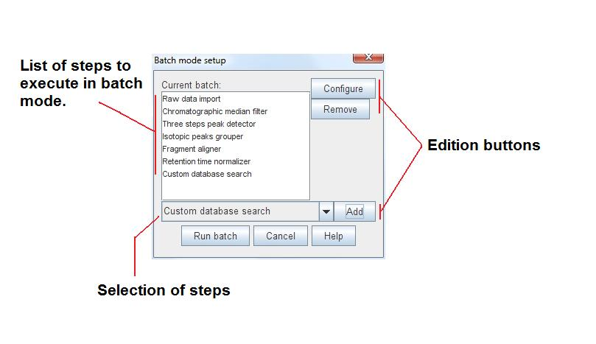

The first step of the batch is performed on those raw data files/peak lists selected by the user at the time of starting the batch. The following steps of the batch are performed on the results obtained by the previous step. For example, if the first step of the batch is Chromatogram builder, it will produce peak lists as a result. The following step of the batch may be Peak list deconvolution, and it will be performed on the peak lists obtained from the first step.

# Raw data file import

## Supported file formats

MZmine 2 can read and process both unit mass resolution and exact mass resolution (e.g. FTMS) data in both continuous and centroided modes, including fragmentation (MSn) scans.

Supported data formats are:

* **mzML** (version 1.0 and 1.1)
* **mzXML** (versions 2.0, 2.1 and 3.0)
* **mzData** (versions 1.04 and 1.05)
* **NetCDF**
* **Thermo RAW** (only on Windows with Thermo Xcalibur installed)

### Thermo RAW support

The support for Thermo RAW is implemented using a small external program RAWdump.exe in *lib/* folder. First, the MZmine importing module creates a separate RAWdump process, which binds to the Thermo Excalibur COM library and extracts the contents of the RAW file as plain text. The MZmine importing module then reads the plain text data and imports it into MZmine. Please see the source file RAWdump.cpp (written in C++) for details.

# Raw data filtering

## Dataset filters

This module comprises various filters that can be applied to the entire raw data file. The preview shows the superposed TIC of all the files:

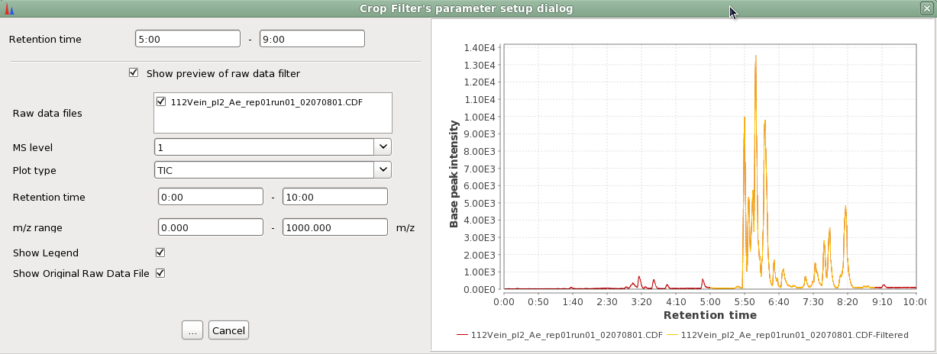

### Crop filter

A new raw data file is created adding only a copy of the scans inside the retention time range defined by the user.

#### Method parameters

Retention time range

Retention time boundary of the cropped region.

## Scan filters

This module comprises various filters that can be applied to the raw data scan by scan. The preview shows the superposed spectra of the scan before and after the filter is applied.  
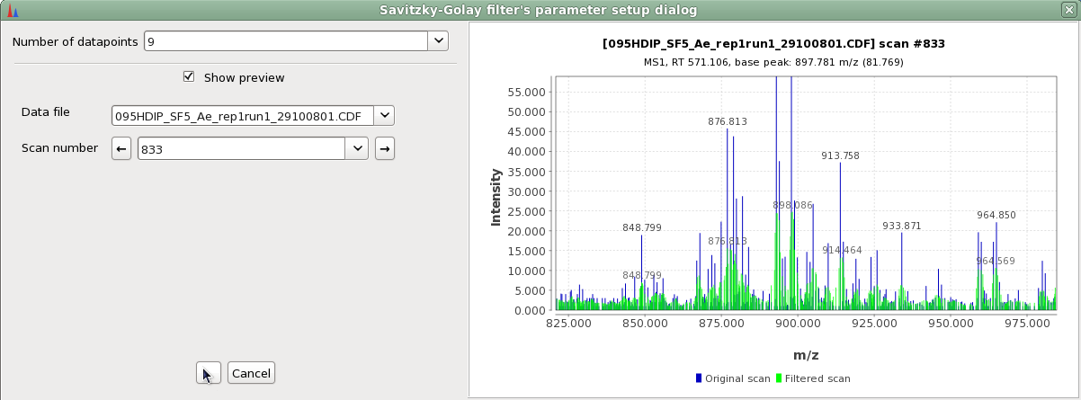

### Mean filter

For each data point, the filter assigns to it the intensity average of all the datapoints inside the user defined window, which is centered in the mass value of this data point. Raw data file before and after the filter was applied:

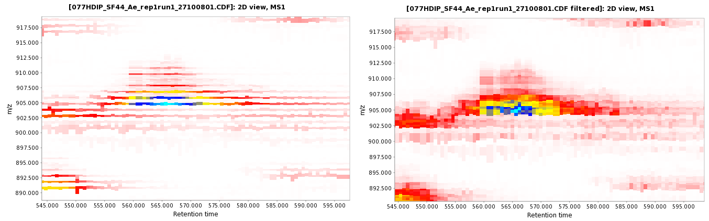

#### Method parameters

Window length

One-sided length of the m/z smoothing window.

### Savitzky Golay filter

The Savitzky–Golay smoothing filter is a type of filter first described in 1964 by Abraham Savitzky and Marcel J. E. Golay.. The Savitzky–Golay method essentially performs a local polynomial regression (of degree k) on a series of values (of at least k+1 points which are treated as being equally spaced in the series) to determine the smoothed value for each point. [http://en.wikipedia.org/wiki/Savitzky-Golay\_smoothing\_filter](http://en.wikipedia.org/wiki/Savitzky%E2%80%93Golay_smoothing_filter)

Raw data file before and after the filter was applied:

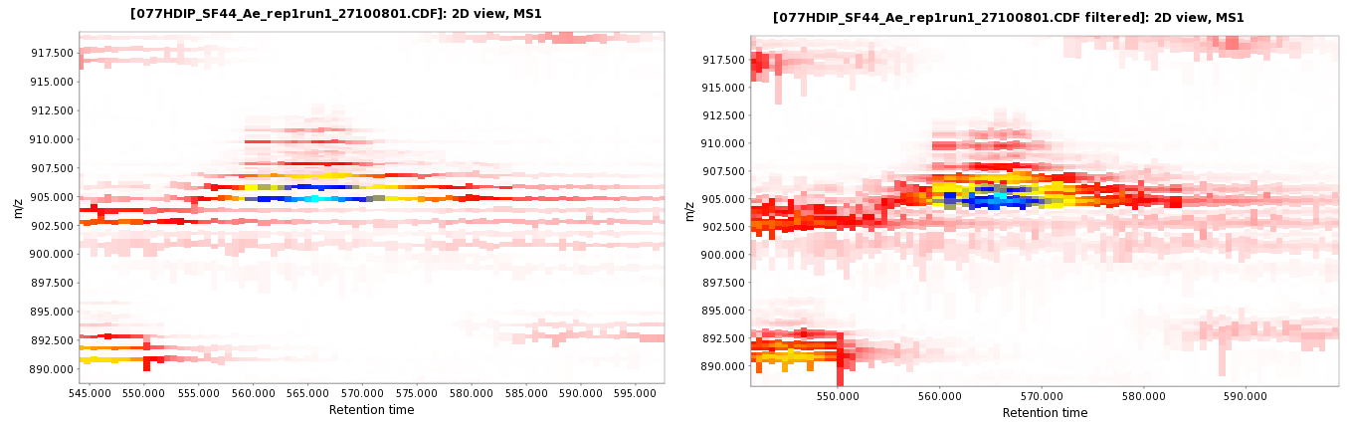

#### Method parameters

Number of datapoints

This number can be 5, 7, 9, 11, 13 or 15.

### Crop filter

The scans out of the retention time range defined by the user are deleted by using this filter. Also, the data points of the remaining scans that are out of the m/z window defined by the user are deleted.

#### Method parameters

m/z range

m/z boundary of the cropped region.

Retention time range

Retention time boundary of the cropped region.

### m/z resample filter

Each scan is divide in m/z bins whose length is defined by the user in the parameters. The mass of the new data point will be in the middle of each m/z bin's space. Its intensity is the average of the intensity of all the data points inside the bin. Raw data file before and after the filter was applied:

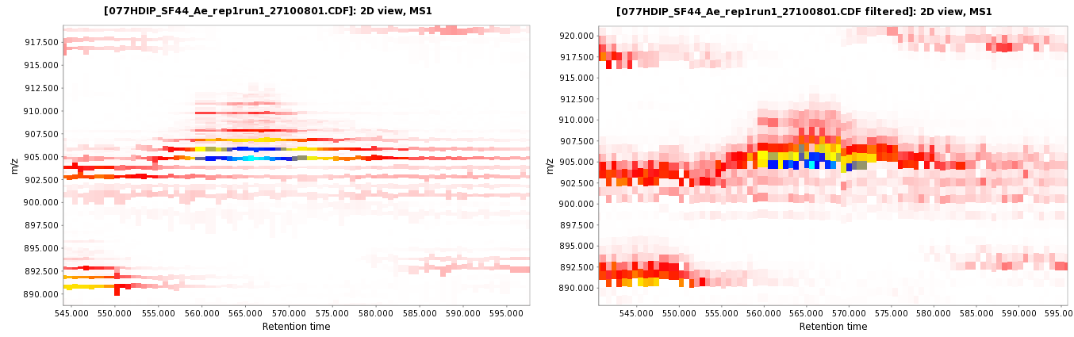

#### Method parameters

m/z bin length

The length of m/z bin.

# Peak detection

## Chromatogram builder

The Chromatogram builder is the main module for peak detection in MZmine 2. Its purpose is to create a list of unique masses which form continuous chromatograms in raw data. Later, these chromatograms may be deconvoluted into individual peaks by the Deconvolution module.

The Chromatogram builder module works in three steps: Mass detection, Filtering and Chromatogram construction. The motivation to divide the process into several steps is to allow the users to optimize each step according to the characteristics of their data.

### Mass detection

In the Mass detection step, individual ions are detected in each mass spectrum. In other words, each mass spectrum is centroided. Several algorithms are provided for this step. The choice of the optimal algorithm depends on the raw data characteristics (mass resolution, mass precision, peak shape).

In case the raw data is already centroided, only one algorithm (Centroid mass detector) can be used. Other algorithms work only with continuous type data.

### Centroid mass detector

This mass detector is suitable for already centroided data. It simply assumes that each signal above given noise level is a detected ion.

#### Method parameters

Noise level

The minimum intensity level for a data point to be considered part of a chromatogram. All data points below this intensity level are ignored.

#### :Eclipse:MZmine SVN:src:net:sf:mzmine:modules:rawdatamethods:peakpicking:chromatogrambuilder:help:Centroid_mass_detector_preview.jpg

### Exact mass detector

This mass detector is suitable for high-resolution MS data, such as provided by FTMS instruments. It first searches for all local maxima within the spectrum. These form candidate ions. After that, exact mass is determined for each candidate ion using the FWHM paradigm (Full Width at Half Maximum). First, the method locates the nearest data points to the peak center at half of the maximum intenstiy (P1, P2, P3, P4). With these four points it is possible to calculate two points (cP1, cP2) that define the width of the peak and the exact mass (the center of the width is considered as exact mass).

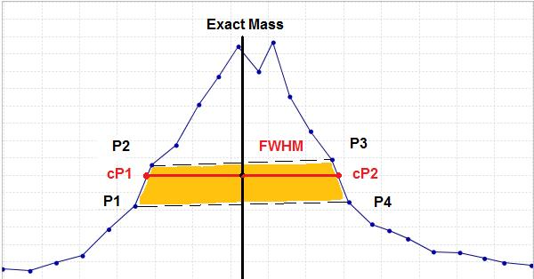

#### Method parameters

Noise level

The minimum intensity level for a data point to be considered part of a chromatogram. All data points below this intensity level are ignored.

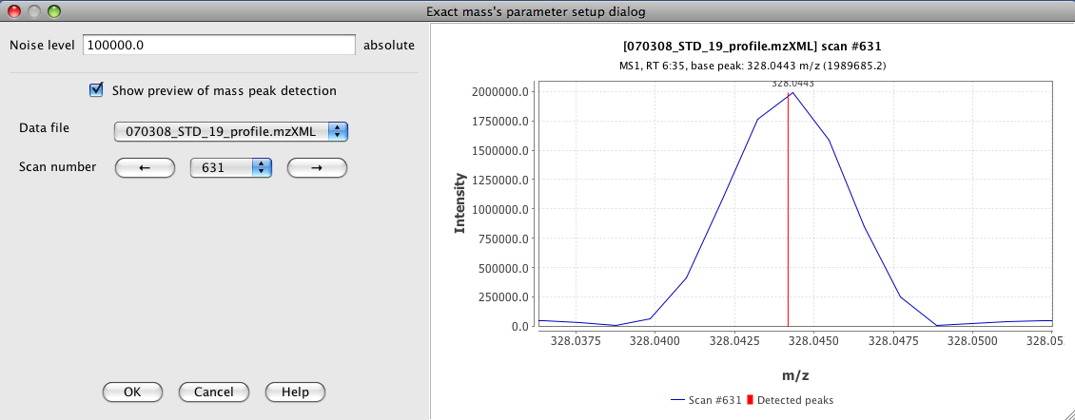

### Local maxima mass detector

This mass detector represents a very simple method, which detects all local maxima within the spectrum, except those signals below the given noise level. The practical usability of this method on real MS data is limited, but it is useful to demonstrate and understand the functionality of mass detection using the preview plot.

#### Method parameters

Noise level

The minimum intensity level for a data point to be considered part of a chromatogram. All data points below this intensity level are ignored.

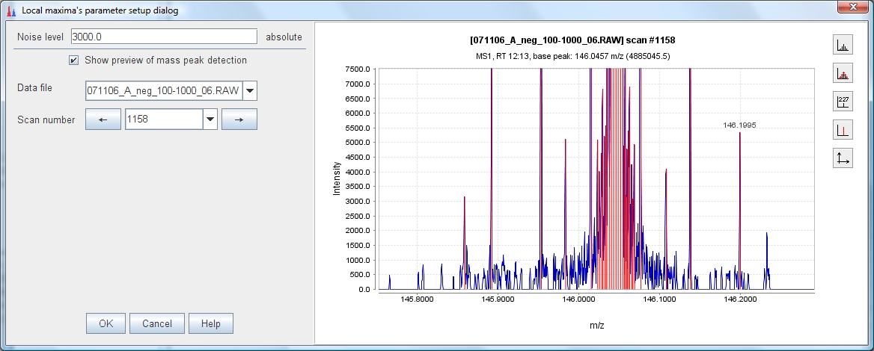

### Recursive threshold mass detector

This mass detector is suitable for continuous data, which has too much noise for the Exact mass detector to be used, but which shows a consistent width of m/z peaks. The algorithm works in a recursive way. Initially, it looks at the whole range of data points. If the m/z width of this range is not within given limits, a minimum data point is found and used to split the range in two parts. The same algorithm is then applied recursively on each part. Recursion continues until all m/z ranges which fit into the given width limits are found. Final m/z values are determined as local maxima of the identified m/z ranges.

#### Method parameters

Noise level

The minimum intensity level for a data point to be considered part of a chromatogram. All data points below this intensity level are ignored.

Min m/z peak width

Minimum acceptable m/z difference between the first and last data point of an ion signal (m/z width). This parameter is used to determine when to stop the recursive search and discard peaks which are too small.

Max m/z peak width

Maximum acceptable m/z difference between the first and last data point of an ion signal (m/z width). This parameter is used to determine when to stop the recursive search.

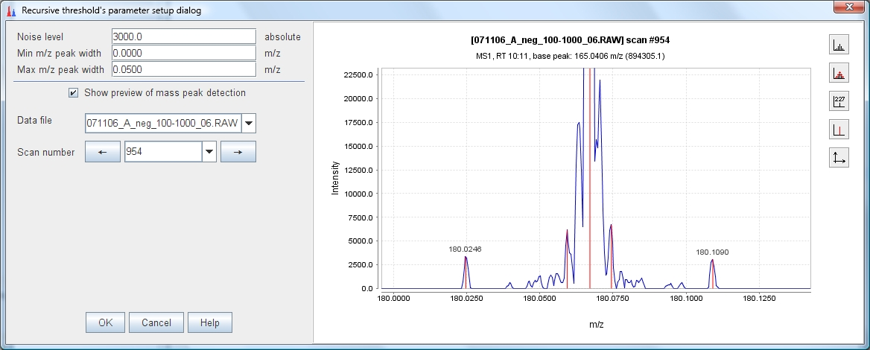

### Wavelet transform mass detector

The Wavelet transform mass detector is particularly suitable for low-resolution and noisy data. The method uses the Mexican Hat wavelet model of the continuous wavelet transform CWT) algorithm. The search of mass spectrum peaks is executed in three steps. First, the data point intensity is converted into wavelet domain. Next, all local maxima of the calculated wavelet are found. Finally, m/z peaks (ions) are declared in those points, where the wavelet has a local maximum. The m/z peak is formed with the selected data point (mass and intensity) using the wavelet and all surrounding data points. The final m/z value of the ion is calculated as an average of m/z values of surrounding data points weighted by their intensity.

#### Mathematical model

In mathematics and numerical analysis, the Mexican hat wavelet is the normalized second derivative of a Gaussian function.

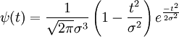  
The parameter *t* is the intensity of each data point in the curve, and *sigma* corresponds to the standard deviation.

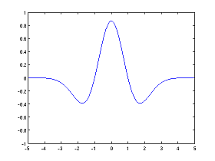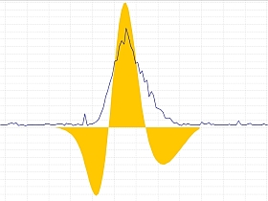

To simplify the process of wavelet calculation, the original function is transformed into two parts, where *Wc* is the wavelet coefficient and *y* is the intensity of the wavelet at certain point. In the following formula, "t" is the *Wavelet window size(%)* parameter.

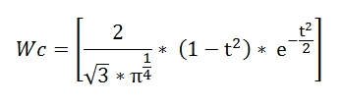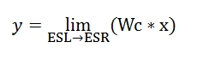

The limits, where the Mexican Hat wavelet is evaluated, are from -5 until 5 (ESL, ESR) and the incremental step used in this range is the result of divide the width of ESL to ESR range by 60,000. The number of coefficients used to calculated the wavelet intensity depends on the *Scale level* parameter.

#### Method parameters

Noise level

The minimum intensity level for a data point to be considered part of a chromatogram. All data points below this intensity level are ignored.

Scale level

This value is the scale factor that either dilates or compresses the wavelet signal. When the scale factor is relatively low, the signal is more contracted which in turn results in a more detailed resulting graph and as a consequence more noisy peaks are detected. On the other hand, when the scale factor is high, the signal is stretched out which means that the resulting graph will be presented in less detail resulting in a smoothed signal.

Wavelet window size (%)

This value is the size of the window used to calculated the wavelet signal. When the size of the window is small, more noisy peaks can be detected. The proper setting of this parameter may help to avoid the undesired noise peaks.

Wavelet window size at 10%:

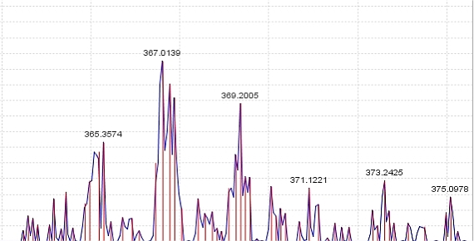  
Wavelet window size at 100%:

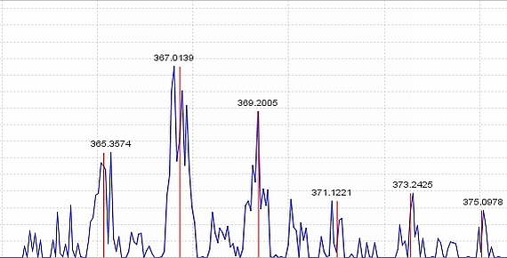

Preview dialog:

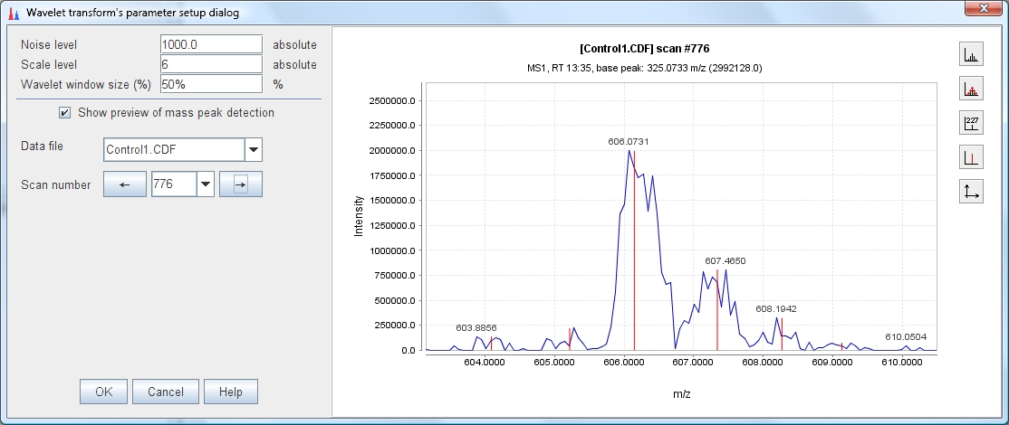

### Filtering

Filtering is an optional operation which may reduce the amount of false chromatograms by removing those m/z signals which can be recognized as noise. The filtering is done on the detected m/z peak lists, raw data is not considered in this step.

### FTMS shoulder peaks filter

Raw data obtained from FTMS (Fourier Transform Mass Spectrometer) instruments often contains false signals around high-intensity m/z peaks, called "shoulder peaks". These signals are residues of the Fourier Transform function and their intensity is usually below 5% of the main (true) m/z peak. The FTMS shoulder peaks filter attempts to remove these false signals. Detected m/z peaks are processed in the order of decreasing intensity. A peak model (shape) is built around each m/z peak using given function and resolution, and those m/z peaks which fall below the model are considered to be shoulder peaks and are removed. The method offers three peak models.

#### Method parameters

Mass resolution of the data

Defines the width of the model, which should be equal to the estimated resolution of the peaks in the raw data. Mass resolution is defined according to the following scheme:  
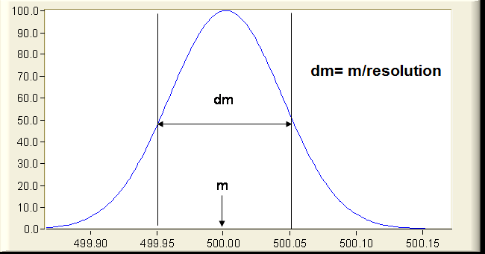

Peak model function

Defines the shape of the model function, as described below.

#### Gaussian peak model

The Gaussian peak model is a characteristic symmetric "bell shape curve" that quickly falls off towards plus/minus infinity, described by the following formula. 

The parameter "a" is the height of the curve's peak, "b" is the position of the center of the peak, and "c" controls the width of the "bell".

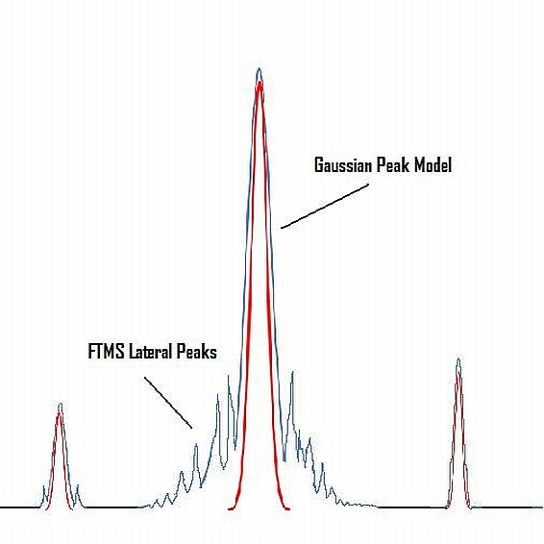

#### Lorentzian peak model

The Lorentzian function (Cauchy-Lorentz distribution) is used for this model.  
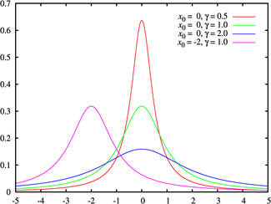

The Lorentzian peak model is described by the following formula:

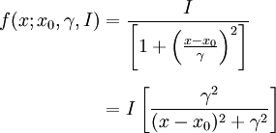  
Where "x0" is the location parameter, specifying the location of the peak of the distribution, and "y" is the scale parameter which specifies the width of the peak.

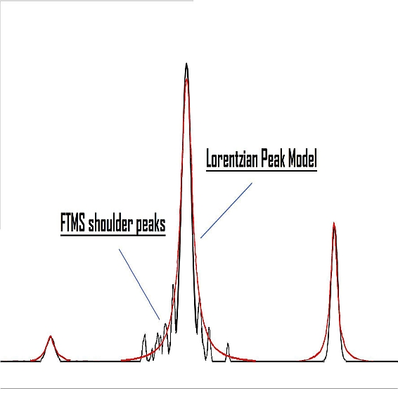

#### Lorentzian extended peak model

This model uses the same mathematical formula as the Lorentzian peak model, but the lower part of the model (below 5% of the intensity) is extended. The width of the peak below 5% intensity is calculated from another Lorentzian peak with 5% of the resolution of the main peak.

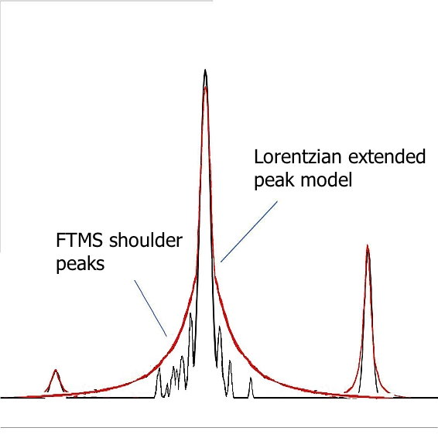

### Chromatogram construction

When mass detection and filtering is finished, m/z data points from each scan must be connected together to form chromatograms.

### Highest data point

This basic method works by maintaining a pool of chromatograms spanning over consecutive scans. For each processed spectrum, the ion list generated by the mass detector (and filtered, if selected) is processed in the order of decreasing intensity and each m/z peak is connected to the appropriate chromatogram according to the m/z tolerance parameter. When no matching chromatogram is found, a new chromatogram is with the m/z value and added to the pool. When a chromatogram is finished (no m/z peak is found to be connected to), its length (time span) and intensity (height) are checked according to user-specified minimal values. Those chromatograms which fit the required parameters are added to the final peak list.

#### Method parameters

Min time span

Minimum time over which the same ion must be connected in order to be recognized as a chromatogram. This parameter should be set by observing the raw data according to the standard length of chromatographic peaks.

Min height

Minimum intensity of the highest data point in the chromatogram. If chromatogram height is below this level, it is discarded.

m/z tolerance

Maximum m/z difference of data points in consecutive scans in order to be connected in the same chromatogram.

## MS/MS peak picker

The MS/MS peak picker is a module for detection of peaks which has a MS/MS (MS2). Its purpose is to look through the whole raw data, looking for MS2 scans and try to make a list of chromatographic peaks which has fragmentation scan (MS2).

First look for each MS2 scan on the selected file, obtains information of his parent scan and if a base peak ion in the specific range is found, a simple chromatographic peak is formed. The verification of a base peak ion helps to avoid cases when the fragmentation (MS2) scan is coming from a random event. Each one of the detected peaks contains only one scan, after this detection is possible to use another tool like Peak detection - Peak extender.

#### Method parameters

m/z window

This is the m/z range (window) where the search of a base peak ion in the parent scan is done.

## Chromatogram deconvolution

Following the detection of chromatograms by the Chromatogram builder, chromatograms have to be deconvoluted into individual peaks. The Deconvolution module provides several algorithms for this purpose.

#### Method parameters

Suffix

This string is added to the end of the name of each processed peak list

Peak recognition

Selection of algorithm for peak recognition (see below)

Remove original peak list

If selected, the original chromatogram is automatically removed and only deconvoluted version will remain

#### Peak recognition algorithms

### Baseline cut-off

This method is very simple and useful to demonstrate the functionality of chromatogram deconvolution. First, the algorithm removes the lowest part of the chromatogram below a baseline level specified by the user. Remaining peaks which span above the baseline level are recognized if they fulfill the minimal requirements of height and length.

#### Method parameters

Min peak height

Minimum acceptable height (intensity) for a chromatographic peak

Min peak duration

Minimum acceptable length (time duration) for a chromatographic peak

Baseline level

Level below which all data points of the chromatogram are removed

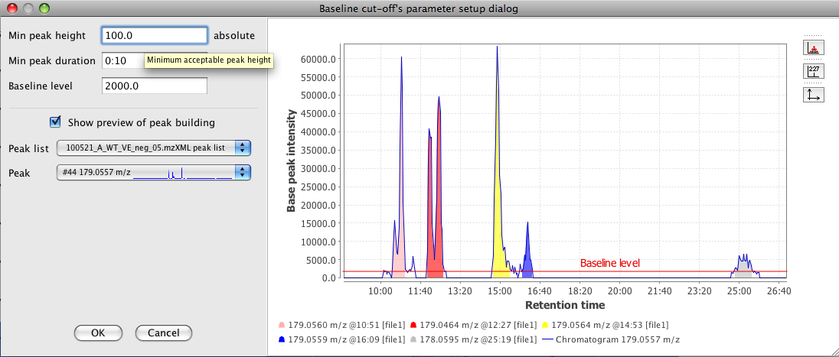

### Noise amplitude

This method is suitable for chromatograms with significant background noise of varying intensity. It works in a similar way as the Baseline cut-off method, but it sets the baseline level individually for each chromatogram, depending on the amplitude of signal noise.

The baseline level is calculated as follows:

1. The intensity range of the chromatogram is divided into bins of the user-specified size (the "Noise amplitude" parameter)
2. The bin with the highest number of data points is found. This bin represents the intensity level of the noise signal.
3. Baseline level is set equal to intensity of the bin with the most data points

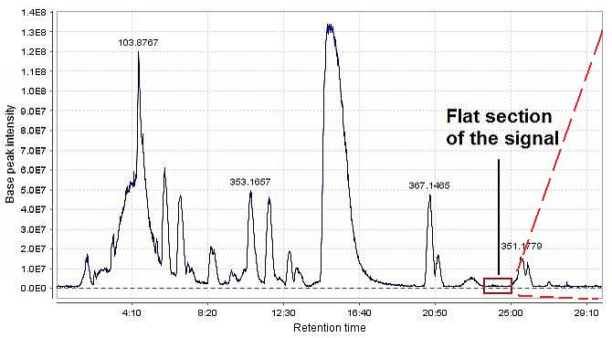

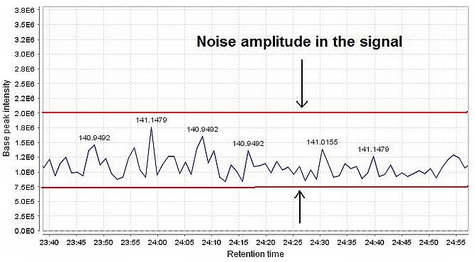

#### Method parameters

Min peak height

Minimum acceptable height (intensity) for a chromatographic peak

Min peak duration

Minimum acceptable length (time duration) for a chromatographic peak

Amplitude of noise

This value is the intensity amplitude of the signal in the noise region

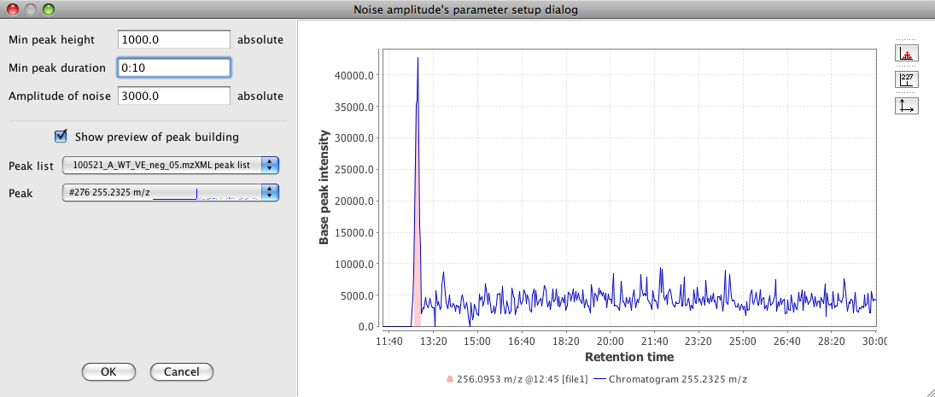

### Savitzky-Golay

This method uses the Savitzky-Golay polynomial (A. Savitzky and M. J. E. Golay, Anal. Chem., 36, 1627 (1964)) to get the second smoothed derivative of the chromatogram intensities. The following figure (left) presents the shape of a Gaussian peak (a), the first derivative (b), and the second derivative (c). The figure at right side shows how the signal (blue line) may be divided into individual chromatographic peaks by observing the second derivative.

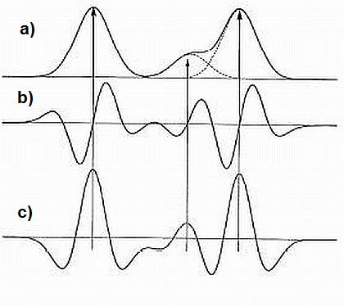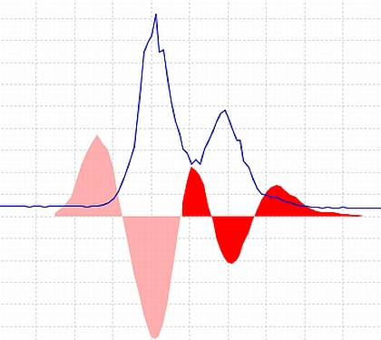

#### Method parameters

Min peak height

Minimum acceptable height (intensity) for a chromatographic peak

Min peak duration

Minimum acceptable length (time duration) for a chromatographic peak

Derivative threshold level

Minimum acceptable intensity in the 2nd derivative for peak recognition

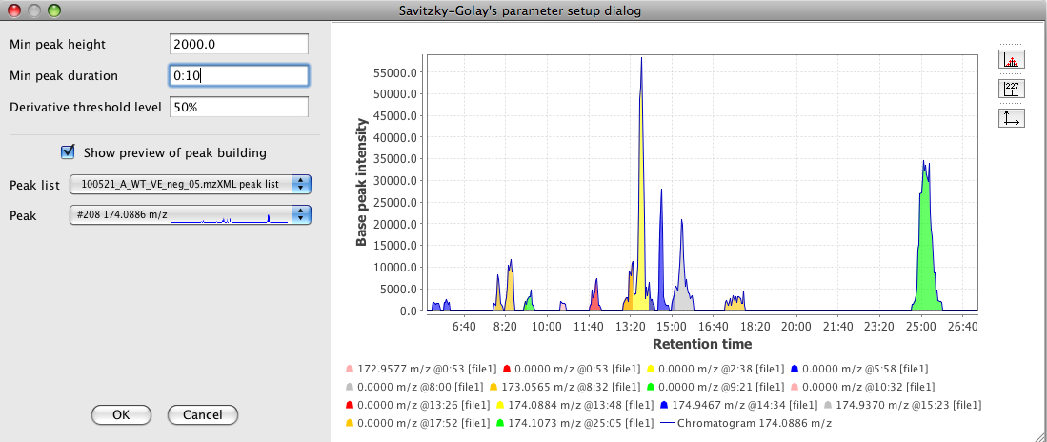

### Local minimum search

This method is suitable for chromatograms with little noise and nice peak shapes. It searches for local minima in the chromatogram and separates individual peaks at these minimal points. Individual peaks are recognized if they fulfill the minimal requirements of height and length. The Chromatographic threshold parameter may be used if the chromatogram contains some background noise.

#### Method parameters

Chromatographic threshold

Threshold for removing noise. The algorithm finds such intensity that given percentage of the chromatogram data points is below that intensity, and removes all data points below that level

Search minimum in RT range

If a local minimum is minimal in this range of retention time, it will be considered a border between two peaks

Minimum relative height

Minimum height of a peak relative to the chromatogram top data point

Minimum absolute height

Minimum absolute height of a peak to be recognized

Min ratio of peak top/edge

Minimum ratio between peak's top intensity and side (lowest) data points. This parameter helps to reduce detection of false peaks in case the chromatogram is not smooth.

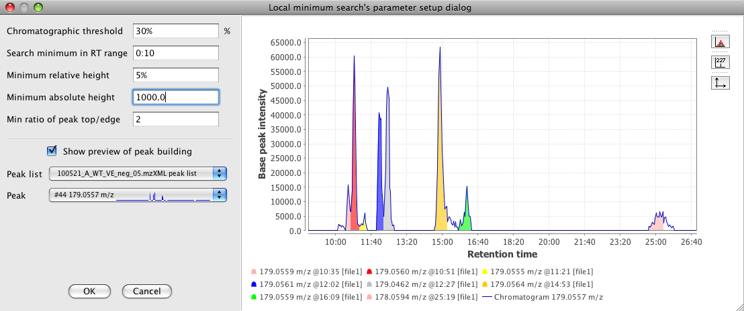

## Peak extender

This module extends the peaks in a peak list in both directions of the retention time. The purpose is mainly to add missing data to peak lists produced by the MS/MS Peak List Builder, which only detects a single data point per peak. The extending is performed scan-by-scan in both directions by searching for data points within given m/z tolerance and above given minimal height. When no data point is found, extending is stopped.

#### Method parameters

Suffix

This string is added to the end of the name of each processed peak list

m/z tolerance

Maximum allowed distance in M/Z between data points in successive scans

Min height

Minimum allowed intensity for succesive scans. When intensity drops below this level, extending is stopped.

Remove original peak list

If selected, the original peak list is automatically removed

Peak list obtained from MS/MS peak detector: 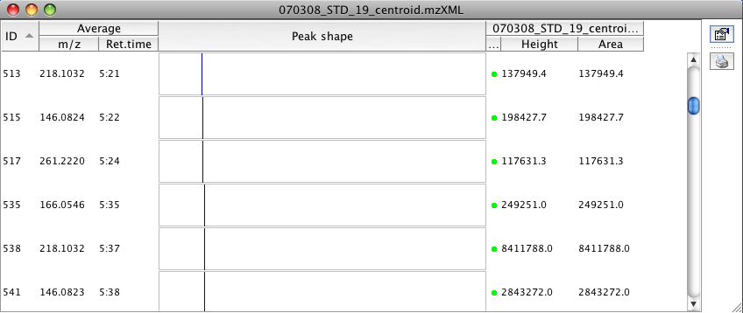

The same peak list after running peak extender: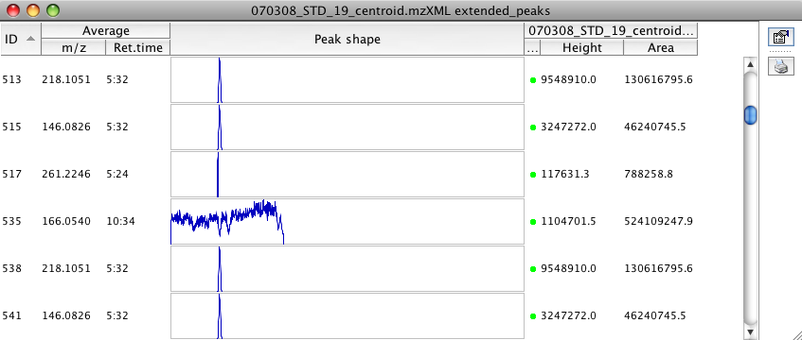

## Peak shape modeler

This module attempts to fit the data points of a peak with an given model. This may help to reduce the noise and improve the quantification by peak areas. At the current stage, this module is only experimental.

#### Method parameters

Suffix

This string is added to the end of the name of each processed peak list

Mass resolution

Mass resolution is the dimensionless ratio of the mass of the peak divided by its width. Peak width is taken as the full width at half maximum intensity (FWHM)

Shape model

The type of peak shape model to use. Triangle is a simple triangle model, designed just to demonstrate the principle. Gaussian (symmetric) and EMG (Exponentially Modified Gaussian; asymmetric) models may provide a better approximation of chromatographic peaks shape.

Remove original peak list

If selected, the original chromatogram is automatically removed and only deconvoluted version will remain

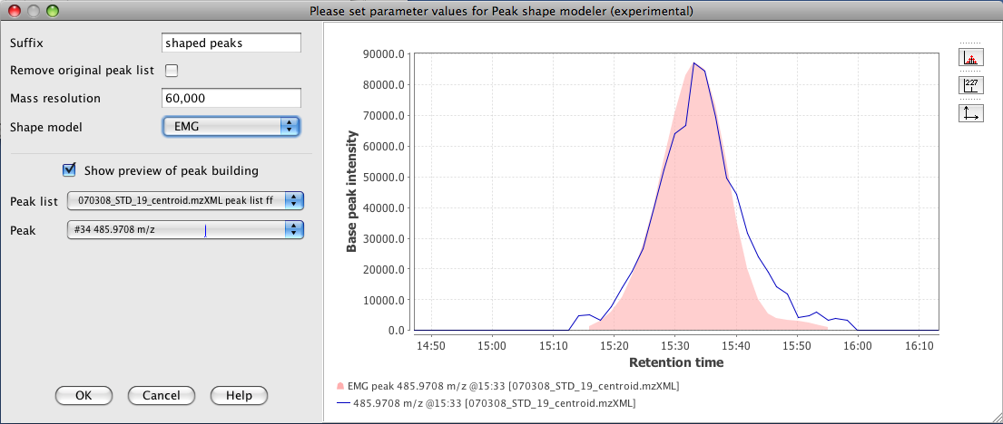

# Isotope patterns

## Isotopic peaks grouper

This module attepts to find those peaks in a peak list, which form an isotope pattern. When isotope pattern is found, the information about the charge and isotope ratios is saved, and additional isotopic peaks are removed from the peak list. Only the highest isotope is kept.

Note that deisotoping is performed **after** the Chromatogram builder and Deconvolution. Therefore, MZmine does not search for isotopic peaks in individual scans, but instead tries to identify those peak list entries, which form an isotope pattern together.

#### Method parameters

Name suffix

Suffix to be added to peak list name

m/z tolerance

Maximum distance in m/z from the expected location of a peak

RT tolerance

Maximum distance in RT from the expected location of a peak

Monotonic shape

If true, then monotonically decreasing height of isotope pattern is required

Maximum charge

Maximum charge to consider for detecting the isotope patterns

Remove original peaklist

If checked, original peaklist will be removed and only deisotoped version remains

#### Deisotoping algorithm

Peaks in the peak list are processed in the order of decreasing height. For each peak, MZmine tries to find the most appropriate charge state by comparing the number of identified isotopes for each possible charge. For each charge state, peaks that fit the m/z and RT distance limits are considered as isotopes. The charge state with the highest number of identified isotopes is selected, and the isotope pattern is generated.

#### Mass difference between isotopes

The difference between neighboring isotopes is a single neutron. The exact mass of 1 neutron is 1.008665 Da, but part of this mass is consumed as a binding energy to other nucleons. This small difference may become significant with high-resolution MS data. The actual mass difference between isotopes depends on the chemical formula of the molecule. Since MZmine does not know the formula at the time of deisotoping, it assumes the default distance of ~1.0033 Da, with user-defined tolerance (the m/z tolerance parameter).

## Isotope pattern checking

Detected charge states and isotope patterns can be observed in the Peak list table and Spectra visualizer:

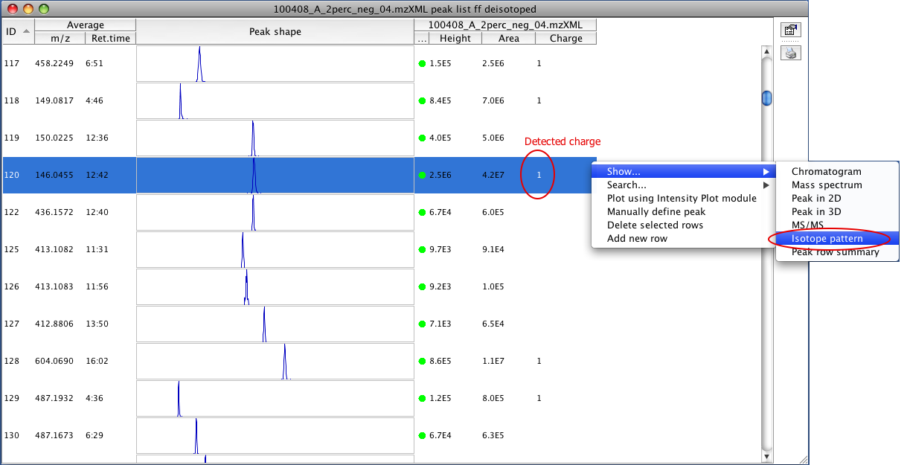

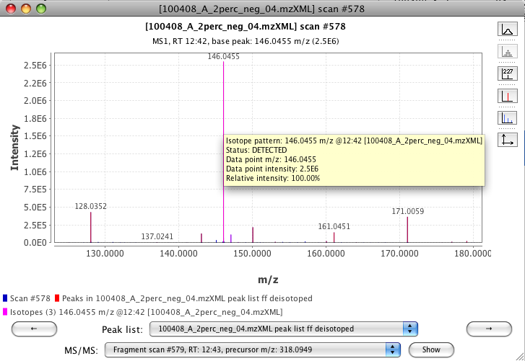

## Isotope pattern prediction

Additionally, user-generated isotope patterns can be added to the Spectra visualizer for comparison with the raw data:

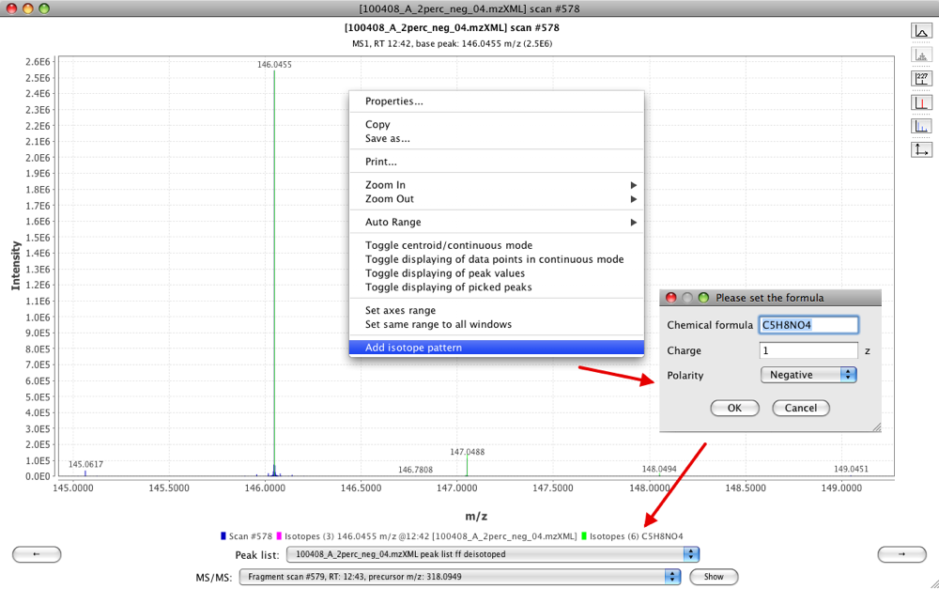

## Isotope pattern comparison

Several modules in MZmine 2 offer the option the compare the isotope patterns of peaks and assign a score (percentage) of similarity to them. This functionality assumes the precision of the m/z values is high (error < 10 ppm). MZmine 2 is using the CDK (Chemistry Development Kit, <http://cdk.sourceforge.net>) library to perform this operation. The algorithm used by CDK is described below.

#### Comparison algorithm

The similarity of two isotope patterns is determined as follows:

1. For each isotope in the first pattern, find a matching isotope in the second pattern, within the 10 ppm difference of mass. If no match is found, the isotope is ignored.
2. A similarity score of the isotope pair is calculated as *pairScore = intensity × (1 - (massDifference + abundanceDifference))*, where *intensity* is the intensity of the first isotope in the pair, *massDifference* is the difference of m/z values and *abundanceDifference* is calculated as *abundanceDifference = 1 - (intensityOfIsotope1 / intensityOfIsotope2)*
3. Finally, a sum of the scores is calculated and divided by the sum of all *intensity* values. The resulting score is therefore normalized to 0.0 - 1.0

# Gap filling

## Peak finder

Following alignment, the resulting peak list may contain missing peaks as a product of a deficient peak detection or a mistake in the alignment of different peak lists. The fact that one peak is missing after the alignment does not imply that the peak does not exits. In most cases it is present but was undetected by the previous algorithms.

This algorithm fills the gaps in the peak list when it is possible according with the parameters defined by the user. The most crucial parameters are "m/z tolerance" and "RT tolerance" which define the window where the algorithm should find the new peak. It is centered in the m/z average and retention time average of the source peak list. Once the best candidate is found inside the window, its intensity and its shape in RT direction is also checked.

It can also add a previous correction of the retention time in the case it is needed. It will change the position of the defined window depending on the prediction of a RT model created using all the already aligned peaks in each pair.

#### RT correction

When RT correction is applied, the algorithm is divided in two main steps. In the first step, one random sample is taken from the multiple peak list and is used as a master list. All the gaps of this master list are filled using all the others samples. For each pair of samples the algorithm creates a model of the retention time. In the second step the master list is used to fill the gaps of the rest of the samples, creating also a retention time model for each pair (as shown in the figure below).

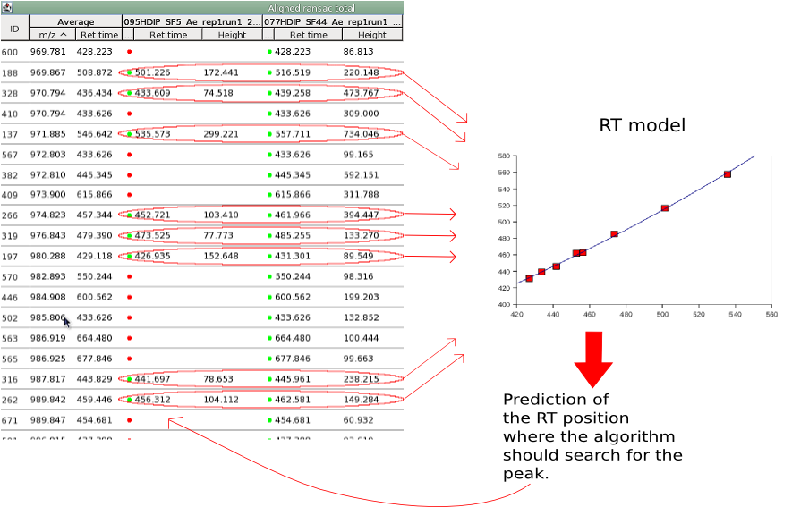

#### Method parameters

Name suffix

Suffix to be added to the peak list name.

Intensity tolerance

This value sets the maximum allowed deviation from expected shape of a peak in chromatographic direction.

M/Z tolerance

This value sets the range, in terms of m/z, to search for possible peak in the raw data. Maximum allowed m/z difference.

Retention time tolerance type

Its value can be relative or absolute. The next parameters should be fill depending on the value chosen in this parameter.

Absolute RT tolerance

This value sets the range, in terms of retention time, to search for possible peak in the raw data. Maximum allowed absolute RT difference.

Relative RT tolerance

This value sets the range, in terms of retention time, to search for possible peak in the raw data. Maximum allowed relative RT difference.

RT Correction

When it is checked, correction of the retention time will be applied to avoid the problems caused by the deviation of the retention time between the samples.

New peak list showing the filled peaks with a yellow mark:  
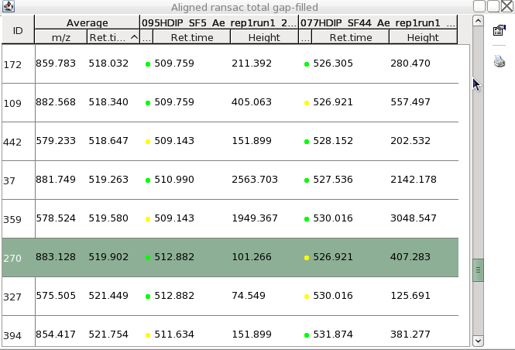

## Same m/z and RT range gap filler

This method fills in gaps in each peak list row by using the same m/z and retention time range as other peaks in the row. The m/z and retention time ranges where the new peaks will be sought are obtained using the ranges of the rest of the peaks in the same row. The minimum value of these ranges is the minimum value in the range of all the peaks in the row and the same happens with the maximum value. The new peak is constructed using the highest data point of each scan within the determined m/z and retention time ranges.

#### Method parameters

Name suffix

Suffix to be added to the peak list name.

# Peak list alignment

## Join aligner

This method aligns detected peaks in different samples through a match score. This score is calculated based on the mass and retention time of each peak and ranges of tolerance stipulated in the parameters setup dialog.

#### Algorithm

The peak alignment algorithm uses:

1. a master list of peaks (L) against which every new sample (Sj) will be matched. When aligning peaks from multiple samples, the master list is initially set to the first sample, and subsequently it will be the combination of samples aligned thus far, with the samples as the columns and the matching peaks as the rows.

2. for every row i in L, a two-dimensional window (where the window size is selected by the user), called Alignment window (AW) defining the ranges of m/z and RT and centered around the average of m/z and RT of all the individual peaks in the row; and

3. a score function to compute the similarity of peaks between L and the new sample Sj inside the alignment window. The score function computes the similarity based on the similarities in m/z, retention time, and optionally on identification, and isotope patterns between the peaks to be matched. The score is calculated as follows:  
*score = ((1 - MZdifference / MZtolerance) × MZweight) + ((1 - RTdifference / RTtolerance) × RTweight)*

The algorithm works as follows. It iterates through the rows of L, and for each row, it looks for peaks within the alignment window in Sj that has to be aligned with L. A score is calculated for each possible match and the pair getting the best score will be aligned.

#### Method parameters

Peak list name

Name of the new aligned peak list

m/z tolerance

This value sets the range, in terms of m/z, for possible peaks to be aligned. Maximum allowed m/z difference

Weight for m/z

This is the assigned weight for m/z difference at the moment of match score calculation between peak rows. In case of perfectly matching m/z values the score receives the complete weight.

Retention time tolerance type

Maximum RT difference can be defined either using absolute or relative value

Absolute RT tolerance

Maximum allowed absolute RT difference

Relative RT tolerance

Maximum allowed relative RT difference

Weight for RT

This is the assigned weight for RT difference at the moment of match score calculation between peak rows. In case of perfectly matching RT values the score receives the complete weight.

Require same charge state

If checked, only rows having same charge (taken from best MS/MS spectra) can be aligned

Require same ID

If checked, only rows having same compound identities (or no identities) can be aligned.

Compare isotope pattern

If both peaks represent an isotope pattern, add isotope pattern score to match score.

Isotope pattern score threshold level

If the score between isotope pattern is lower, discard this match.

New aligned peak list showing peaks from 3 different samples:

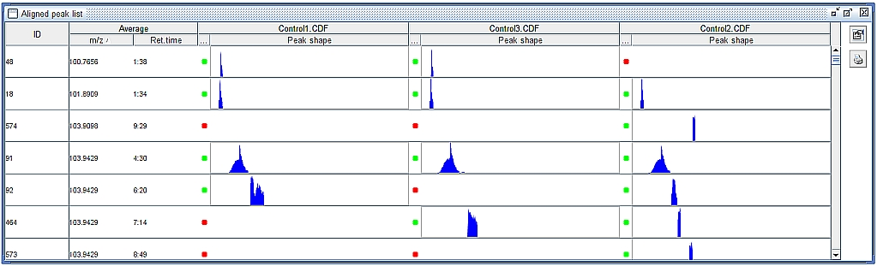

## RANSAC aligner

This method is an extension of the Join aligner method. The alignment of each sample is done against a master peak list which is taken from the first sample in the first round, and from the average of all aligned peak lists in every round. It corrects any linear or non-linear deviation in the retention time of the chromatograms by creating a model of this deviation.

This picture shows an example of two samples with a non-linear deviation in the retention time:

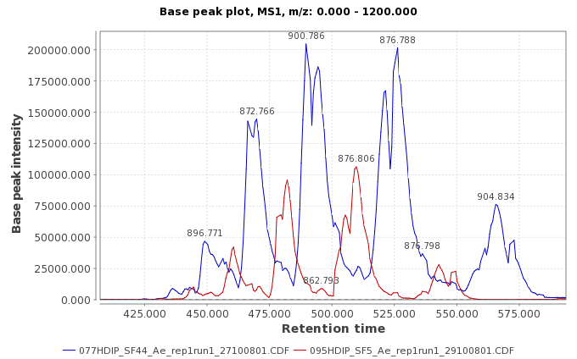

The "deviation" model for the retention time is created by taking some corresponding points from the peak list of two samples using the RANSAC algorithm (<http://en.wikipedia.org/wiki/RANSAC>) and using a non-linear regression method to fit the model.

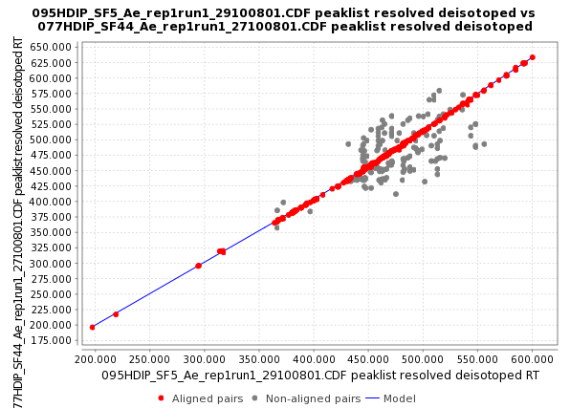

This picture shows a preview of the model where the red dots represents the aligned peaks taken using RANSAC algorithm, and the blue line represents the fitted model using a non-linear regression.

Using this model, the algorithm can predict the shift in the retention time along all the peak list and use the match score function, used also in Join Align algorithm, to match the peaks. This score is calculated based on the mass and retention time of each peak and ranges of tolerance stipulated in the parameters setup dialog.

#### Method parameters

Peak list name

This is the suffix to identify the new aligned peak list in Peak list frame of desktop.

m/z tolerance

This value sets the range, in terms of m/z, to verify for possible peak rows to be aligned. Maximum allowed m/z difference.

Retention time tolerance after correction

This value sets the range, in terms of retention time, to verify for possible peak rows to be aligned. Maximum allowed retention time difference.

Retention time tolerance

This value sets the range, in terms of retention time, to create the model using RANSAC and non-linear regression algorithm. Maximum allowed retention time difference.

RANSAC Iterations

Maximum number of iterations allowed in the algorithm to find the right model consistent in all the pairs of aligned peaks. When its value is 0, the number of iterations (k) will be estimate automatically.

Minimum Number of Points

% of points required to consider the model valid (d).

Threshold value

Threshold value (seconds) for determining when a data point fits a model (t).

Linear model

Sometimes the shift in the retention time between the peaks in the samples is not constant making that the model shape is non linear in some specific cases. This option should be selected only if the model has to be linear.

#### Parameter setup dialog

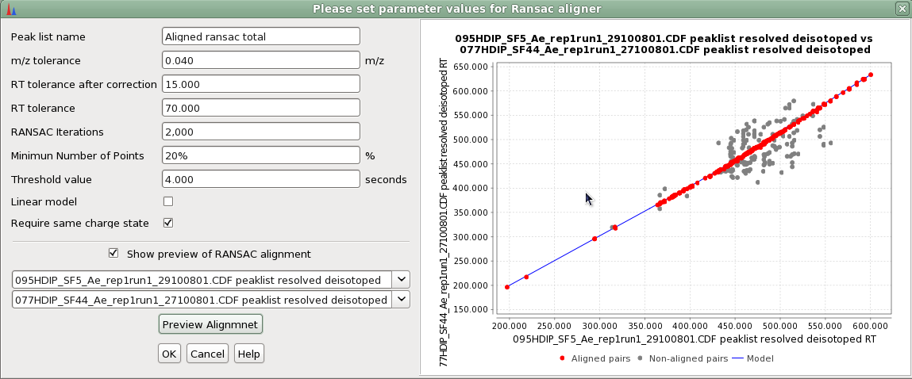

#### Parameter optimization

The three first parameters (“m/z tolerance”, “RT tolerance after correction” and “RT tolerance”) define 2 bi-dimensional windows with the same "altitude" (m/z tolerance) and different "longitude" (RT tolerances). The first window (“m/z tolerance” – “RT tolerance after the correction”) sets the space where the matching peak should be present, and the second windows (“m/z tolerance” – “RT tolerance”) sets the total space where RANSAC algorithm will be applied. So, "RT tolerance" should be as big as the maximum deviation in the retention time among all the chromatogram, and "RT tolerance after the correction" can be more flexible and depends on the complexity of the data. If the data contains only a few peaks and the separation is good, the window can be bigger than "RT tolerance" window and it will improve the recall without including mistakes. This parameter should not affect the final results very much.

RANSAC is a non-deterministic algorithm, and the probability of finding a good result increases with increasing the number of iterations. If the user sets "0 iterations" into the parameter "RANSAC iterations" the algorithm will automatically set the optimum number of iterations depending on the number of data points. In case there is a lot of data points it is better to limit this parameter, even though the result could be non-optimal. The preview module can assist to set this parameter.

The parameter "Minimum number of points" should be an estimation of the proportion of the data points inside the model. It is important not to get models composed by few data points, which do not correspond to the real model. All the models, which contain less proportion of data points won't be taken into account by RANSAC algorithm.

Threshold value represents the width of the model and it depends on the nature of the data. If this parameter is too big it can lead to deviation of the model. The preview function can help us, also in this case, to set the optimal value.

The last parameter depends on whether the deviation in the retention time in the data can be considered linear or not. If the deviation in the retention time is linear, a simple linear regression will be used to fit the model.

# Normalization

## Linear normalizer

Linear normalizer divides the height (or area) of each peak in the peak list by a normalization factor, determined according to the Normalization type parameter. Each column (raw data file) of the peak list is normalized separately. In other words, normalization factor is determined independently for each raw data file.

#### Method parameters

Suffix

This string is added to the end of the name of each processed peak list

Normalization type

Selection of the normalization factor

Peak measurement type

Selection of either peak height or peak area, which will be used to calculate the normalization factors

Remove original peak list

If selected, the original peak list is automatically removed

### Normalization factors

Average intensity

Average height (or area) of all peaks in the column is calculated and used as the normalization factor

Average squared intensity

Same as Average intensity, but values are squared before calculating the average

Maximum peak intensity

Maximum height (or area) in the peak list column is used as the normalization factor

Total raw signal

Sum of the height (or area) of all peaks in the peak list column is used as the normalization factor

## Retention time normalizer

The retention time normalizer attempts to reduce the deviation of retention times between peak lists, by searching for common peaks in these peak lists and using them as normalization standards. The method requires multiple peak lists of different samples, processed by Deconvolution, but prior to alignment. Ions which are present in all given peak lists (according to given m/z and RT tolerance and minimum intensity) in exactly one instance are considered as standards. Retention times of the standards are then averaged and equalized in all samples, and retention times of all other peaks are adjusted according to the retention times of neighboring standard peaks.

#### Method parameters

Suffix

This string is added to the end of the name of each processed peak list

m/z tolerance

Maximum allowed m/z difference

Retention time tolerance

Maximum allowed retention time difference

Minimum standard intensity

Minimum height of a peak to be selected as normalization standard

Remove original peak list

If selected, the original chromatogram is automatically removed

The folowing screenshot shows two peak lists (top) normalized by the Retention time normalizer (bottom) with the following parameters: m/z tolerance = 0.1, RT tolerance = 1:00, Minimum standard intensity = 1E6. The red color shows which peaks were selected as standards. The retention time of standards was averaged, and retention time of other peaks was adjusted accordingly (blue color).

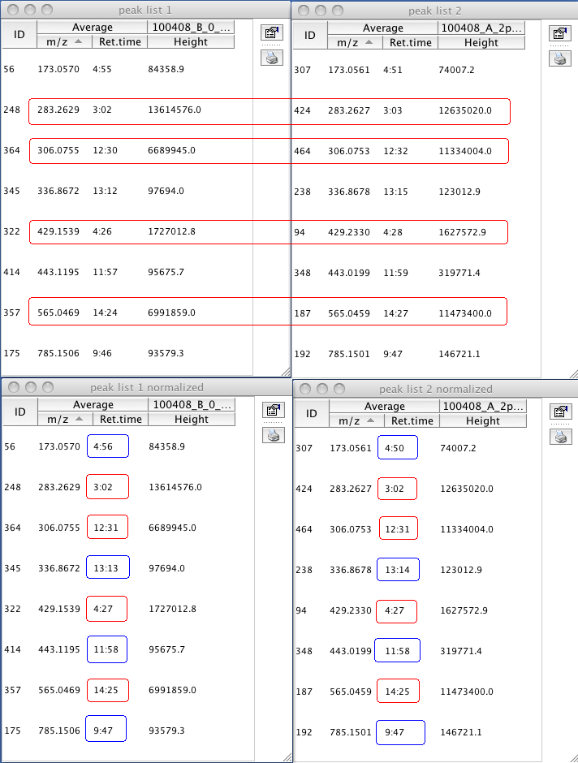

## Standard compound normalizer

The purpose of this module is to reduce the deviation between samples caused by different detection efficiency. Internal standard peaks must be present in the detected samples. Peak list must be aligned prior to normalization. User can select one or multiple internal standard peaks, which must be present in all raw data files. Then peak height (or area) of each peak is normalized by either the nearest standard or a weighted contribution of all standards.

#### Method parameters

Suffix

This string is added to the end of the name of each processed peak list

Normalization type

Normalize intensities using either only one (nearest) standard or using a weighted contribution of all selected standards, weighted by distance. The distance of the standard peak to the peak being normalized is calculated as *distance = MZvsRTBalance \* (MZdifference) + (RTdifference)*.

Peak measurement type

Selection of either peak height or peak area, which will be used to calculate the normalization factors

m/z vs RT balance

Used in distance measuring as coefficient of m/z difference.

Remove original peak list

If selected, the original peak list is automatically removed

Standard compounds

List of peaks for choosing the normalization standards

# Identification

## Adduct Search

#### Definition of an adduct ion

An ion formed by interaction of two species, usually an ion and a molecule, and often within the ion source, to form an ion containing all the constituent atoms of one species as well as an additional atom or atoms.

This method identifies common adducts (selected by the user) in a single peak list. The adducts are identified by 2 conditions: 1) the retention time of the original ion and the adduct ion should be same and 2) the mass difference between the original ion and the adduct must be equal to one of the adducts selected by the user.

MZmine has a built-in list of common adducts and their masses. On top of this list, the user can specify a custom adduct mass.

The following figure shows a spectrum with a phosphate adduct ion.  
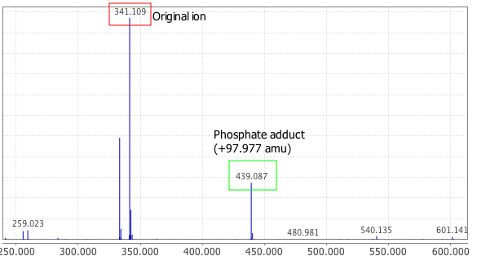

The following figure shows a peak list showing two identified "Deuterium" adducts:  
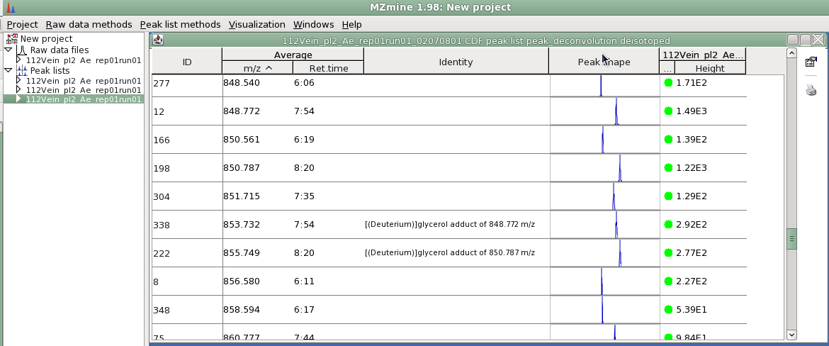

#### Method parameters

RT tolerance

Maximum allowed difference of retention time to set a relationship between peaks

Adducts

List of adducts, each one refers a specific distance in m/z axis between related peaks

Custom adduct value

Specific distance in m/z axis between related peaks for custom adduct

m/z tolerance

Tolerance value of the m/z difference between peaks

Max adduct peak height

Maximum height of the recognized adduct peak, relative to the main peak

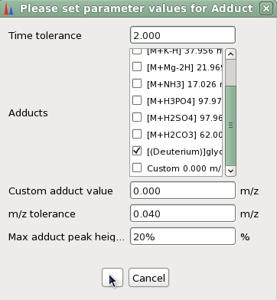

## Peak complex search

This method attempts to identify ion complexes, that is pairs of ions which appear together at the same retention time, and form an ion complex which contains both smaller ions as components. The complexes are identified by 2 conditions: 1) the retention time of the component ions and the complex ion should be same and 2) the sum of the masses of the component ions must be equal to the mass of the complex, except the mass change caused by ionization, such as (de)protonization.

The following figure shows an example of a spectrum with an ion complex in positive ESI mode (both ions are protonized):

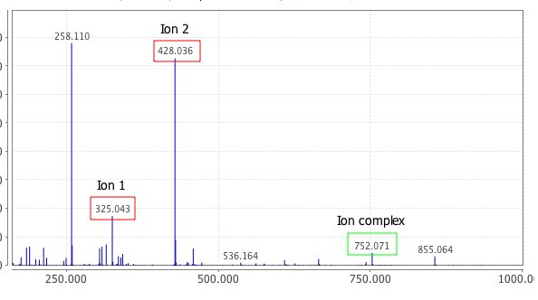

#### Method parameters

Ionization method

Type of ion used to calculate the neutral mass

RT tolerance

Maximum allowed retention retention time difference to set the relationship between peaks

m/z tolerance

Tolerance value of the m/z difference between peaks

Max complex peak height

Maximum height of the recognized complex peak, relative to the highest of component peaks

## Custom database search

This method assigns identity to peaks according to their m/z and retention time values. The user provides a database of m/z values and retention times in CSV format (see below).

#### Method parameters

Database file

Name of file that contains information for peak identification

Field separator

Character(s) used to separate fields in the database file

Field order

Order of items in which they are read from database file. Order may be changed by dragging the items with mouse.

Ignore first line

Check to ignore the first line of database file

m/z tolerance

Maximum allowed m/z difference to set an identification to a peak

RT tolerance

Maximum allowed retention time difference to set an identification to a peak

#### Database file

Database file has to be provided in CSV format (Comma-Separated Values). Such files can be exported from a spreadsheet software such as MS Excel, or edited manually using a text editor. The following examples shows the structure of the database file:

ID,m/z,Retention time (min),Identity,Formula

1,175.121,24.5,Arginine,C6H14N4O2

2,133.063,11.9,Asparagine,C4H8N2O3

3,134.047,11.7,Aspartate,C4H7NO4

Setup dialog for the identification using the above example database file:  
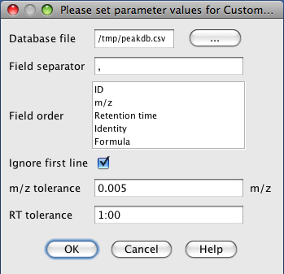

## Online database search

This module allows identification of peaks or whole peak lists using an on-line compound database. Databases are queried for the calculated neutral mass of the peak and matching compounds are returned.

Selection of the peak for identification:  
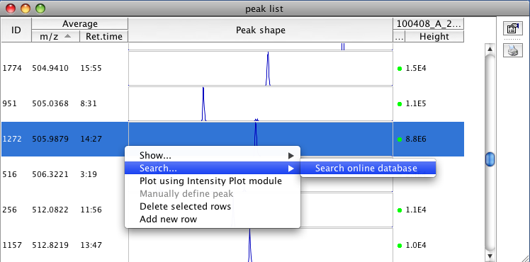

Results of database query:  
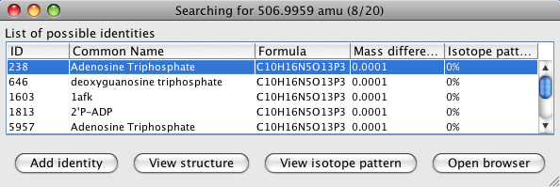

Displaying the structure of the database compound:  
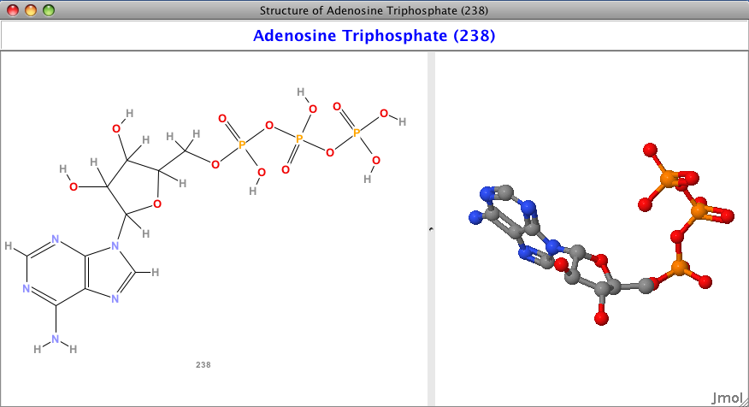

#### Method parameters

Database

On-line database to search (see below)

Peak m/z

Detected m/z value of the peak. This is set automatically according to the peak subjected to identification.

Charge

Charge of the peak being identified. This value is used to calculate the neutral mass.

Ionization method

Type of ionization that produced the peak subjected to identification. This is used to calculate the neutral mass.

Neutral mass

This value is automatically calculated from the parameters above. The neutral mass represents the final search term for querying the on-line database.

Number of results

Limit for the number of results to be retrieved from the on-line database.

Mass tolerance

Tolerance of the neutral mass for searching the database.

Isotope pattern filter

If selected, only results which fit the required isotope pattern similarity score will be returned.

Isotope pattern score threshold

The score required for the isotope pattern filter.

### Supported databases

Currently supported databases are listed below. Support for other databases may be implemented as addititonal plugins.

#### PubChem

PubChem database (<http://pubchem.ncbi.nlm.nih.gov/>) contains millions of chemical compound structures.

#### KEGG

KEGG database (<http://www.genome.jp/kegg/>) contains metabolites and other biomolecules present in natural metabolic pathways.

#### HMDB

The Human Metabolome Database (HMDB) (<http://www.hmdb.ca/>) contains over 7,000 known metabolites found in human body.

#### METLIN

The METLIN database (<http://metlin.scripps.edu/>) contains over 20,000 metabolites.

## Fragment search

This method identifies fragment peaks using MS/MS scan data. Fragment ions are usually produced from another, bigger ion, in the ionization source. Such additional signals represent an undesired noise.

Fragments are identified by 2 conditions: 1) the retention time of the original ion and the fragment ion should be same and 2) the MS/MS pattern of the original ion must be found in the data set and is must contain a peak with the same mass as the fragment ion.

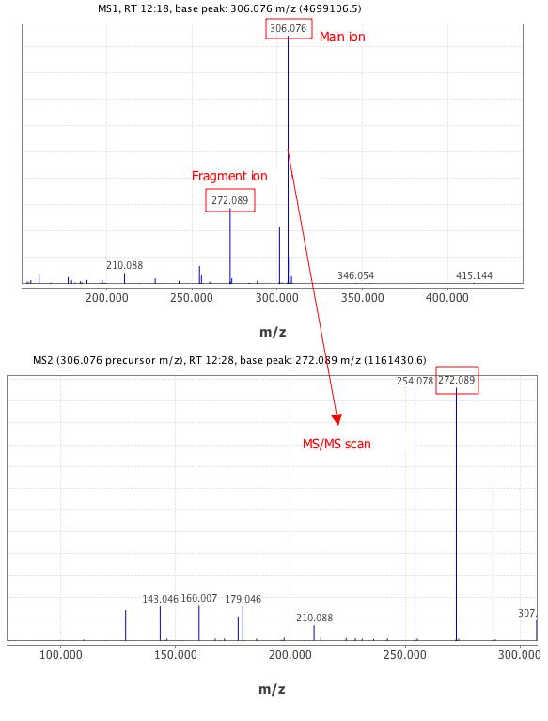

#### Method parameters

RT tolerance

Maximum allowed retention time difference to set a relationship between peaks

m/z tolerance of MS2 data

Tolerance value of the m/z difference between peaks in MS/MS scans

Max fragment peak height

Maximum height of the recognized fragment peak, relative to the main peak

Min MS2 peak height

Minimum absolute intensity of the MS2 fragment peak. Signals below this level will be ignored.

## Glycerophospholipid prediction

Glycerophospholipids are compounds with a well-defined structure (see <http://en.wikipedia.org/wiki/Glycerophospholipid>). This method calculates all possible m/z values of single-charged ions of phospholipids according to given restrictions. If a peak with any of these m/z values is present in the peak list, it is identified as the predicted phospholipid peak. Retention time is not considered in this method.

#### Method parameters

Type of lipids

Selection of glycerophospholipis to consider

Minimum fatty acid length

Minimum length of the fatty acid chain

Maximum fatty acid length

Maximum length of the fatty acid chain

Maximum number of double bonds

Maximum number of double bonds in one fatty acid chain

m/z tolerance

Maximum allowed m/z difference

Ionization method

Type of ion used to calculate the ionized mass

## Mascot search

This module allows the identification of chromatographic peaks by Mfascot Software (Matrix Science) using their most intense fragment scan (MS2). A mascot generic format file (MGF) is generated from a peaklist and submitted to a previous configured Mascot server. This module is currently experimental.

#### Method parameters

The list of parameters is build base on the Mascot MS/MS Ion search form page. The list of parameters or options can vary depending of the Mascot version.

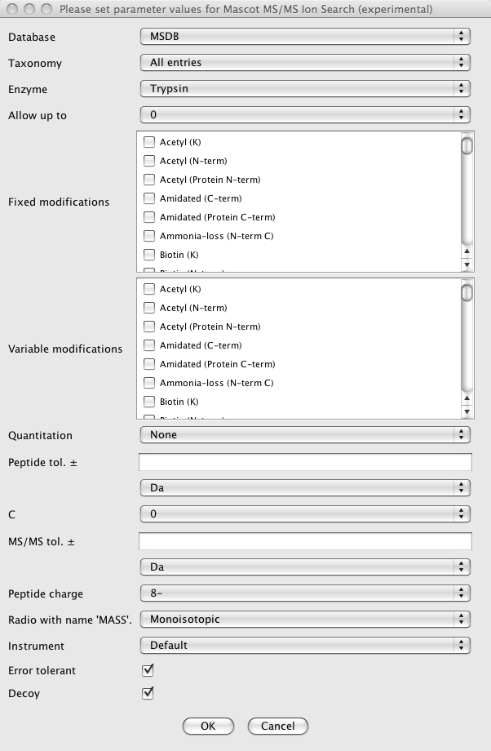

# Peak list filtering

## Duplicate filter

Two peak will consider duplicates when their m/z and retention time difference are lower than the tolerances set by the user. When two duplicates are found, the row with the median of all peaks aera smaller, will be deleted.

#### Method parameters

Name suffix

This is the suffix to identify the new aligned peak list in Peak list frame of desktop.

M/Z tolerance

Maximum m/z difference between duplicate peaks.

RT tolerance

Maximum retention time difference between duplicate peaks.

Require same identification

If the checkbox is selected duplicate peaks must have the same identification.

Remove source peak list after filtering

It the checkbox is selected the source peak list will be remove and the filtered version remains.

## Rows filter

This module deletes all rows in a selected peak list that do not meet the requirements defined by the user. These requirements can be the minimum number of peaks inside the row, the minimum number of peaks in a isotope pattern or a m/z vs retention time window.

#### Method parameters

Name suffix

This is the suffix to identify the new aligned peak list in Peak list frame of desktop.

Minimum peaks in a row

Minimum number of peaks in a row required to keep it.

Minimum peaks in an isotope pattern

Minimun number of peaks in an isotope pattern required to not remove the row.

Minimum m/z

Minimum average m/z value in a row required to not remove it.

Maximum m/z

Maximum average m/z value in a row required to not remove it.

Minimum retention time

Minimum average retention time value in a row required to not remove it.

Maximum retention time

Maximum average retention time value in a row required to not remove it.

Only identified?

If the checkbox is selected only indentified rows will be filtered.

Remove source peak list after fitering

It the checkbox is selected the source peak list will be remove and the filtered version remains.

# Data analysis

## Projection plots

High-dimensional data, meaning data that requires more than two or three dimensions to be represented, can be difficult to interpret. One approach to simplification is to assume that the data of interest lies on an embedded non-linear manifold within the higher-dimensional space. If the manifold is of low enough dimension then the data can be visualised in the low dimensional space.

### Principal component analysis (PCA)

Principal component analysis (PCA) involves a mathematical procedure that transforms a number of possibly correlated variables into a smaller number of uncorrelated variables called principal components.

PCA is mathematically defined as an orthogonal linear transformation that transforms the data to a new coordinate system such that the greatest variance by any projection of the data comes to lie on the first coordinate (called the first principal component), the second greatest variance on the second coordinate, and so on. PCA is theoretically the optimum transform for given data in least square terms. (<http://en.wikipedia.org/wiki/Principal_component_analysis>)

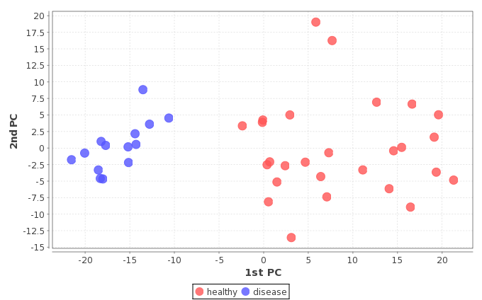

### Sammon's projection

The main use for the projection is visualization. Sammon's projection is useful for preliminary analysis in all statistical pattern recognition, because a rough visualization of the class distribution can be obtained, especially the overlap of the classes.

Denote the distance between ith and jth objects in the original space by d\*ij, and the distance between their projections by dij. Sammon's projection aims to minimize the following error function, which is often referred to as Sammon's stress:

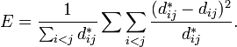

The minimization can be performed either by gradient descent or by other means. (<http://en.wikipedia.org/wiki/Sammon%27s_projection>)

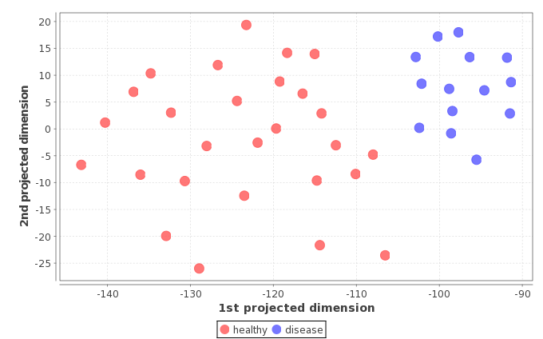

### Curvilinear distance analysis (CDA)

This algorithm trains a self-organizing neural network to fit the manifold and seeks to preserve geodesic distances in its embedding. It based on Curvilinear Component Analysis (which extended Sammon's mapping), but uses geodesic distances instead.

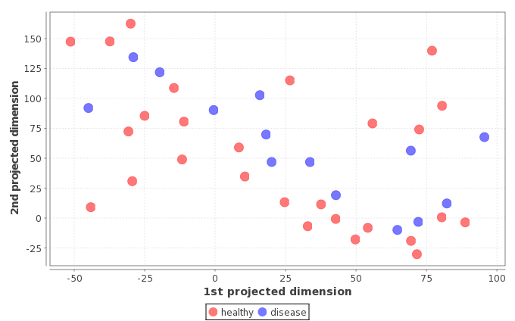

#### Method parameters

Data files

Raw data files correspondent to the samples selected to bi in the projection plot.

Coloring style

The dots corresponding to every sample can be colored depending on the sample's parameter state or on the file.

Peak measuring approach

It can take two values: height or area. The projections will be calculated using one of this two values.

Peaks

Peaks that will be taken into account to create the projection plot.

Component on X-axis

This parameters is only enabled in PCA algorithm and it allows to the user to choose the principal component on X axis.

Component on Y-axis

This parameters is only enabled in PCA algorithm and it allows to the user to choose the principal component on Y axis

## CV and Logratio analysis

### Coefficient of variation (CV)

The coefficient of variation (CV) is a normalized measure of dispersion of a probability distribution. It is defined as the ratio of the standard deviation to the mean. (<http://en.wikipedia.org/wiki/Coefficient_of_variation>)

The advantage of the CV is that it is unitless. This allows CVs to be compared to each other in ways that other measures, like standard deviations or root mean squared residuals, cannot be. The standard deviations of two variables, while both measure dispersion in their respective variables, cannot be compared to each other in a meaningful way to determine which variable has greater dispersion because they may vary greatly in their units and the means about which they occur. The standard deviation and mean of a variable are expressed in the same units, so taking the ratio of these two allows the units to cancel. This ratio can then be compared to other such ratios in a meaningful way: between two variables (that meet the assumptions outlined below), the variable with the smaller CV is less dispersed than the variable with the larger CV.

(<http://www.ats.ucla.edu/stat/mult_pkg/faq/general/coefficient_of_variation.htm>)

### Logratio analysis

This analysis shows a difference of each peak between two groups of samples. It is defined as the ratio of the natural logarithm of the ratio of each group average to the natural logarithm of 2: *logratio = ln(groupOneAverage / groupTwoAverageg) / ln(2)*

#### Method parameters

Peak measuring approach

It can take two values: height or area. The coefficient of variation an the logratio analisys will be calculated using one of this two values.

#### Screenshot of the resulting plot

CV plot:  
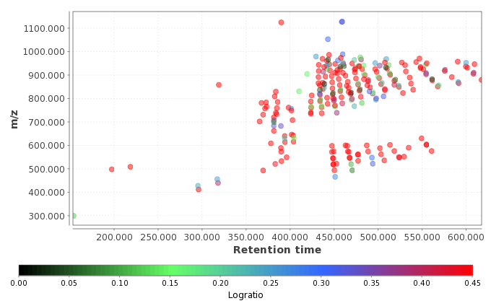

Logratio plot:  
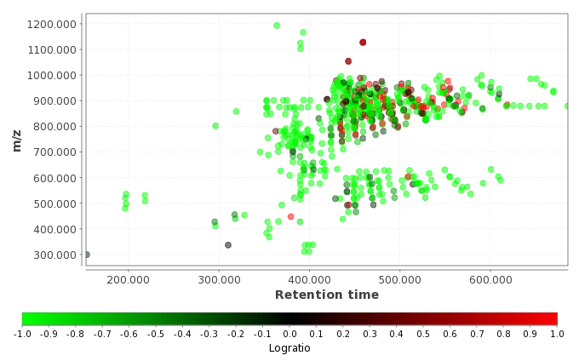

# Peak list export and import

## CSV export

This module exports the contents of the peak list into a CSV (Comma-Separated Values) format file, which can later be processed by MS Excel or other tools. CSV file export is a one-way operation, CSV files cannot be imported back to MZmine.

#### Method parameters

Filename

Name of file where the exported data is saved

Field separator

Columns in the new CSV file will be separated by this character (typically a comma)

Export elements

Please select which columns from the peak list will be exported into the CSV file

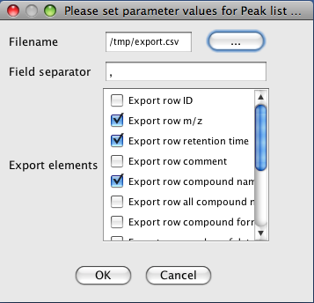

## XML export and import

These module allow exporting the contents of the peak list into an XML file. Only the contents of the peak list are saved, raw data are not included in the export. Default extension for the exported file is MPL (MZmine Peak List). The file may be optionally compressed by the ZIP algorithm prior to saving. Both compressed and uncompressed XML files can be imported back to MZmine, although the connection to the raw data files will be lost.

#### Method parameters

Filename

Name of file where the exported data is saved

Compressed file

The XML file is compressed by ZIP algorithm before saving

#### XML file structure

In the beginning of the XML file, information about the peak list (name, number of rows, applied methods) is saved. Following that, basic information about the raw data files structure (scan numbers and their retention times) is saved for each raw data file in the peak list.

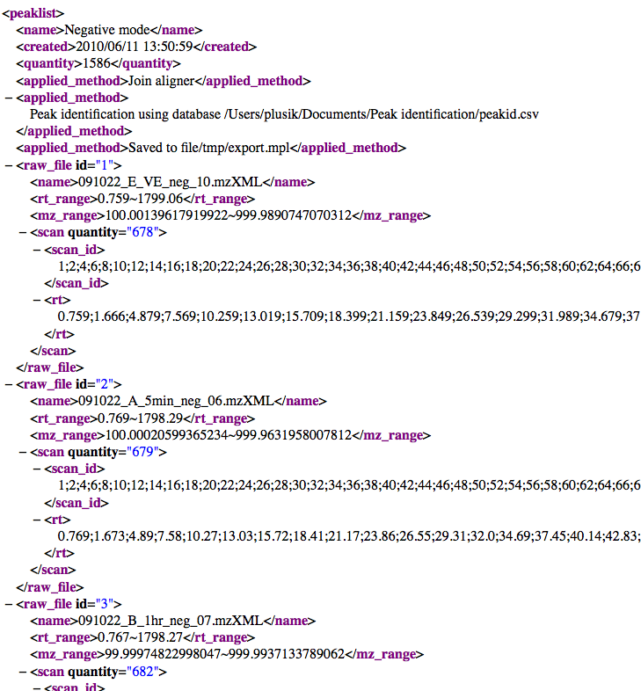

Following the definition of raw data files, each peak list row is saved into a <row> element. It contains the information about peak identity and all individual peaks in the row. For each peak, basic information about its data points (scan numbers, m/z and intensity values) is saved as arrays of *double* type encoded by Base64 encoding (the <mzpeak> element). This information is necessary for showing the peak shape in the peak list table visualizer, when the XML peak list is imported back into MZmine.

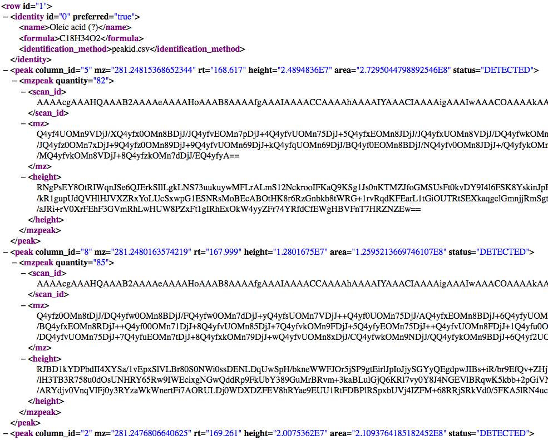

# Project saving and loading

Project saving and loading is done by two separate modules. All project components (raw data, peak lists, identification etc.) are saved into a single file.

## Project file format

Project file has a *.mzmine* extension by default. It is in fact a compressed ZIP archive, which contains several files:

* **MZMINE\_VERSION** contains the version number of MZmine that saved the project file
* **configuration.xml** contains configuration of all MZmine modules at the time of saving
* **Raw data file #*number* *name*.scans** for each raw data file in the project
* **Raw data file #*number* *name*.xml** for each raw data file in the project
* **Peak list #*number* *name*.xml** for each peak list in the project

#### Scans data file format (.scans)

This file contains all data point information for all scans of the raw data file in binary form. Data is saved scan after scan, from first data point to the last, with no delimiters. Each data point is saved as 8 bytes, where the first 4 bytes represent the m/z value in *float* Java type and the second 4 bytes represent the data point intensity value in *float* Java type.

#### Raw data file XML file format

The structure of the XML description of each raw data file in the project is saved in the following form:

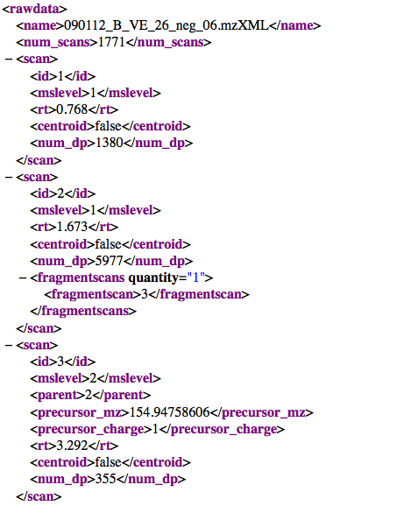

Please refer to the MZmine source code for more detailed information about the project file format.

#### Peak list XML file format

The structure of the XML description of each peak list in the project is saved in the following form:

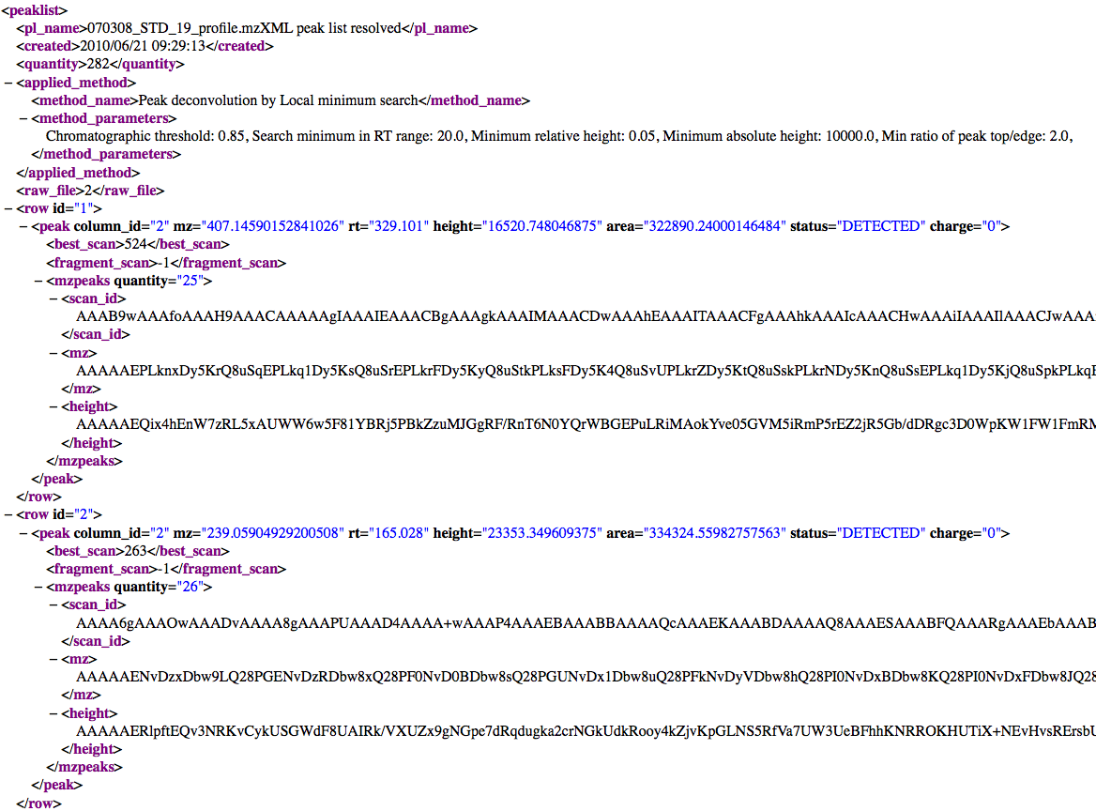

This format is similar to the format of a peak list exported to XML file (see the Peak list export to XML section). Please refer to the MZmine source code for more detailed information about the project file format.

# Visualization

## TIC/XIC visualizer

This tool displays a plot of two dimensions, where X axis corresponds to retention time and Y axis is the intensity level of the signal. This visualization of the raw data corresponds to the chromatographic appearance of the data.

Generally this plot is well used in MZmine to display chromatographic peaks.

#### Parameters

Raw data files

List of raw data files to display in TIC visualizer, with the possibility to chose one, many or all of them. The TIC will display all the chromatograms in the same plot.

MS level

This refers to the scan level (MS1,MS2,... ,MSn) to be used to display the chromatogram.

Plot type

Type of Y value calculation. TIC shows the sum of intensities, base peak shows the maximum intensity.

Retention time

Retention time (X axis) range.

m/z range

Range of m/z values. If this range does not include the whole scan m/z range, the resulting visualizer is XIC type.

Selected peaks

List of chromatographic peaks to display in TIC visualizer. This is available only if a related peaklist to the selected raw data file exists in the current project.

Additionally in the parameters window, the button "Set automatically" allows the user to set all the ranges automatically. MZmine will use the maximum ranges allowed by the raw data.

#### Functionality

This plot is using the third part library JfreeChart for its basic functionality. To zoom in, drag the mouse from left to right, selecting the area to zoom. To zoom out drag the zoom from right to left.

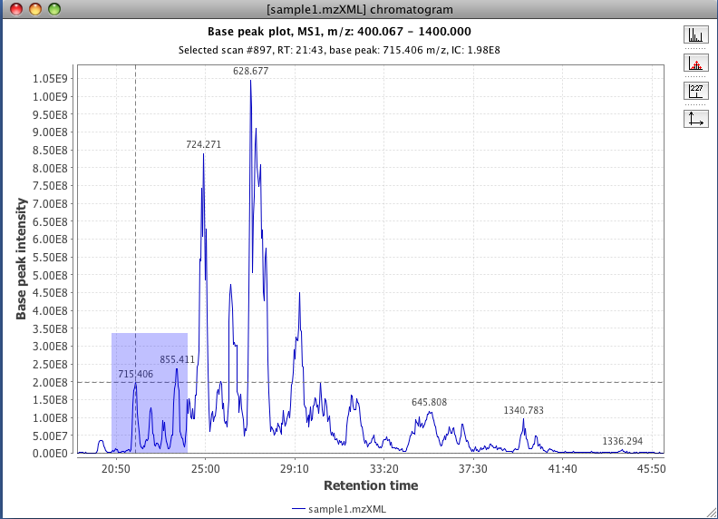

In the right part of the plot exist a group of icons which functionality is also included in a pop-up menu, which appears when you make right click on the plot area.

When the mouse is passed over the plot a tool tip appears showing the information of that data point. If left click is done a crosshair lines will appear, indicating the selected position. Using the first button from the right panel is possible to visualize the spectrum.

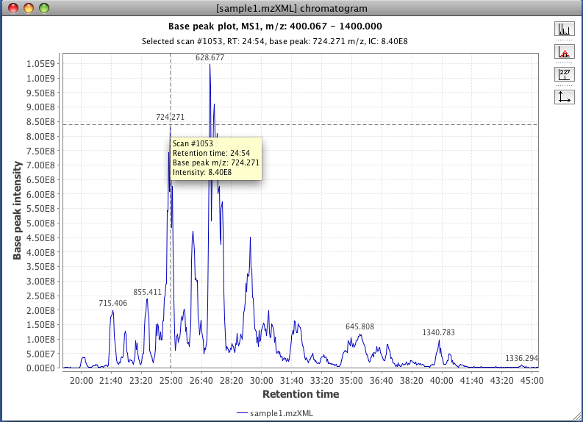

To display the data points in the plot use the second icon on the right panel.

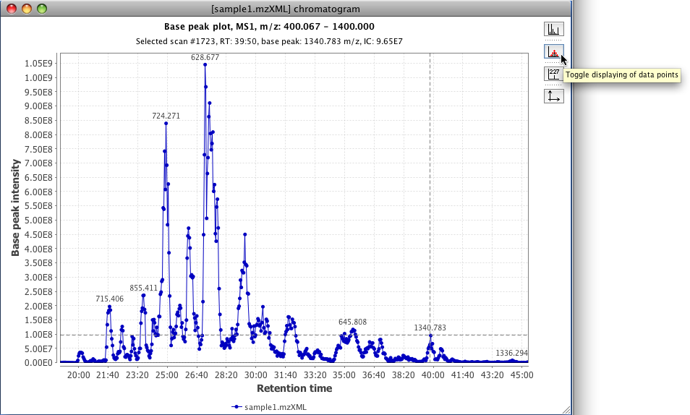

To display the label of the data points or modified the range of the axis use the third and fourth button from the right panel respectively.

It is possible to display the data from other raw data files in the same TIC plot window by using the options in the pop-up menu (left click on the plot area).

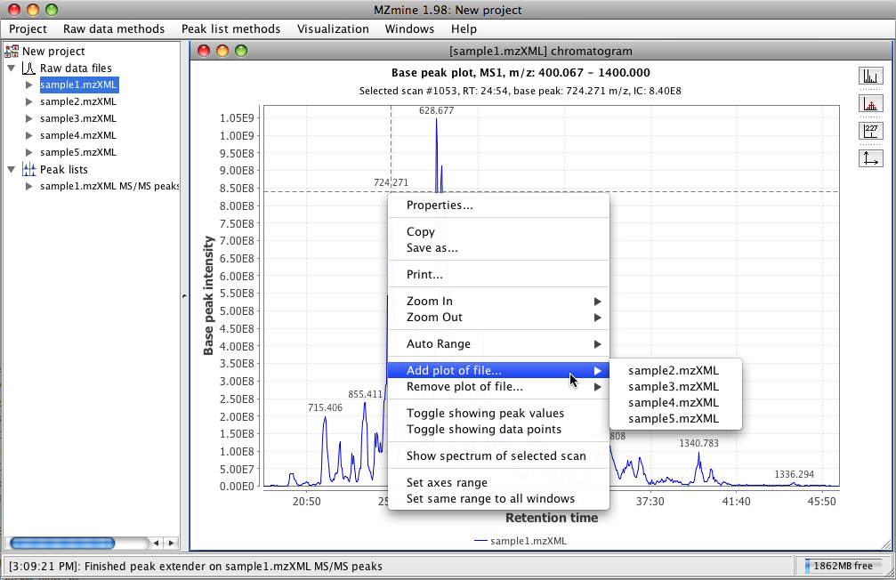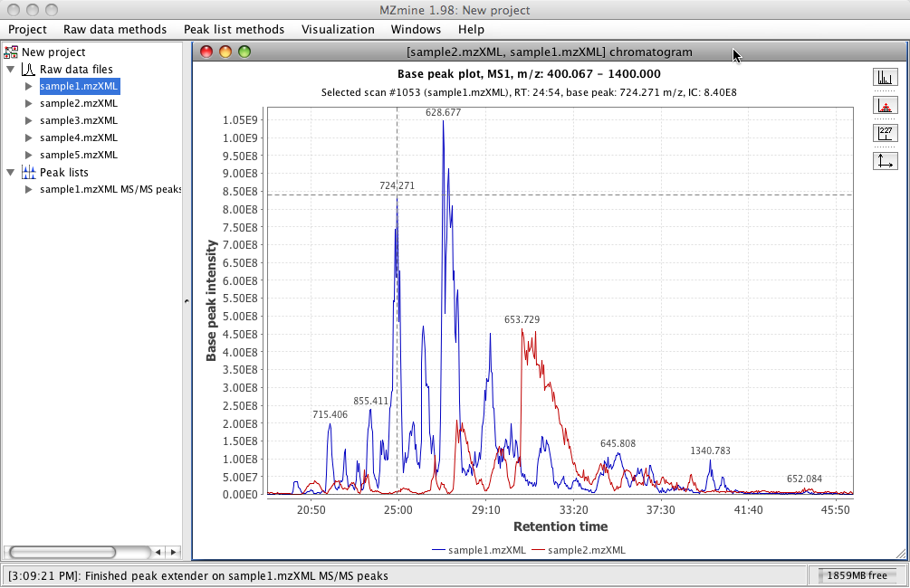

The submenu contents and option called "Set same range to all windows", which apply the same x and y ranges values to other TIC plot windows in the current project.

## Spectra plot

This tool displays all the ions from a selected scan. It shows a plot of two dimensions, where X axis corresponds to m/z value and Y axis is the intensity of the ion signal.

#### Parameters

Scan number

This is the number that identify the scan to be visualized.

#### Functionality

This plot is using the third part library JfreeChart for its basic functionality.

To zoom in, drag the mouse from left to right, selecting the area to zoom. To zoom out drag the zoom from right to left.

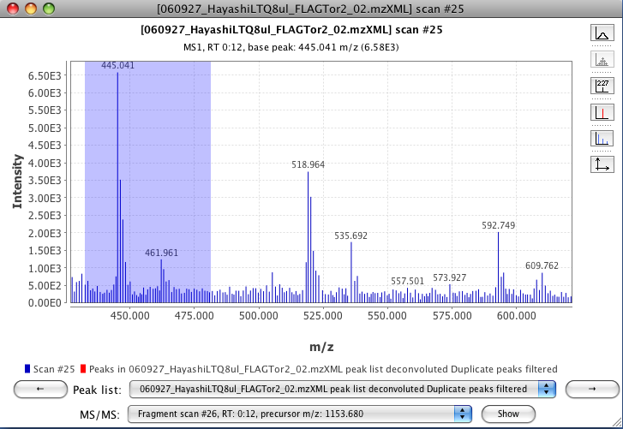

In the right part of the plot exist a group of icons (toolbar) which functionality is also included in a pop-up menu, which appears when you make right click on the plot area.

The first icon correspond to the visualization mode (centroid or continuous).

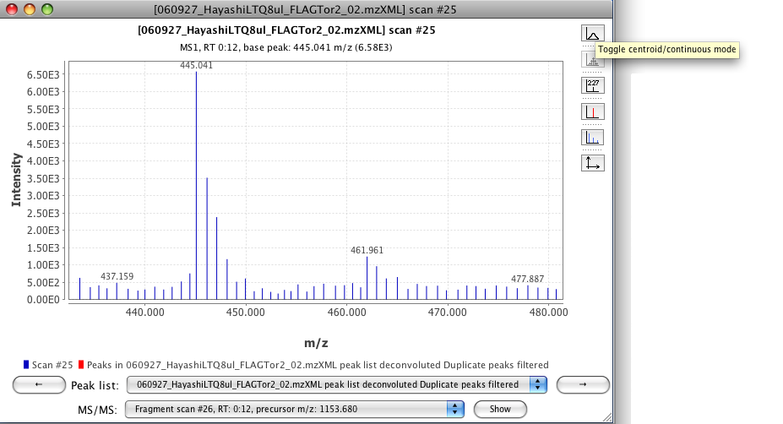

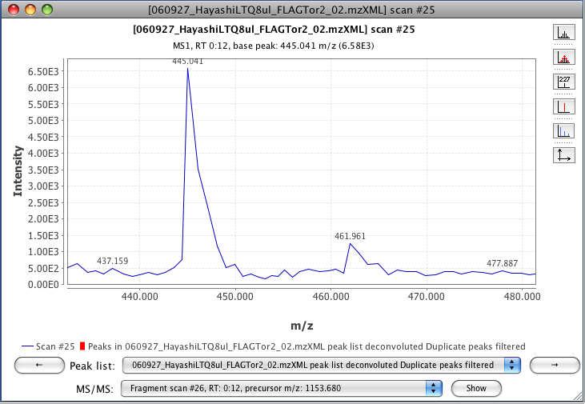

To display the data points in the plot use the second icon on the right panel.

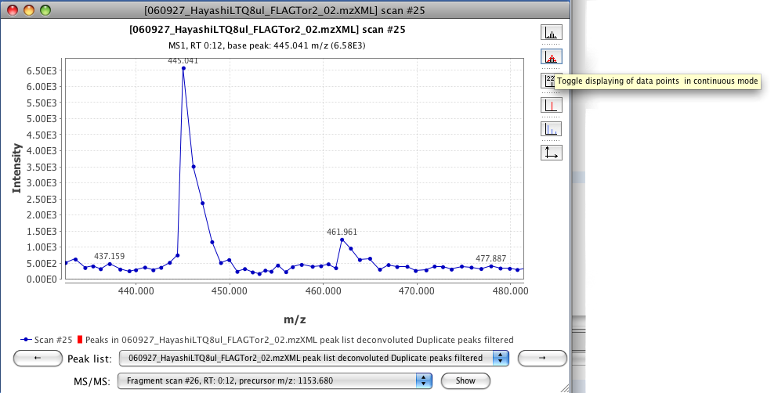

To display the label of the data points use the third button of the right panel.

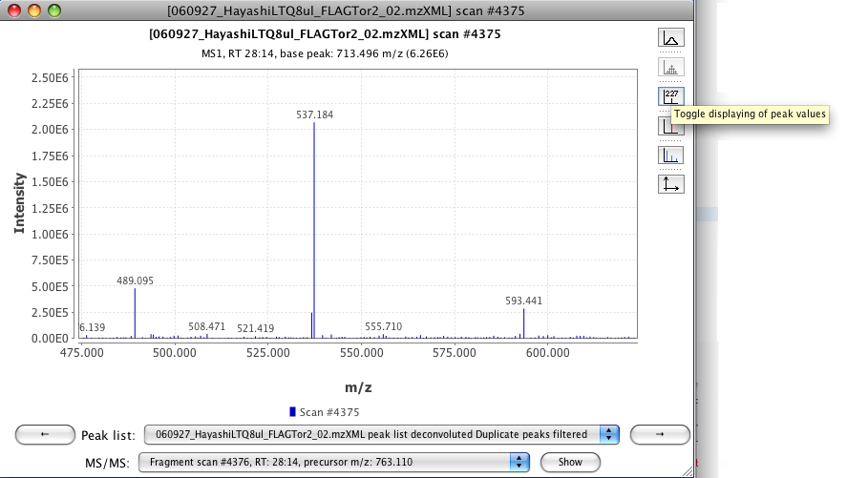

It is possible to display the selected ions to form a chromatographic peak, by default this option is activated. The selected ion appears in color red. If the user toggles the button of "Toggle displaying picked peaks", the color of the ion change to the normal color (blue) and the tool tip information also changes.

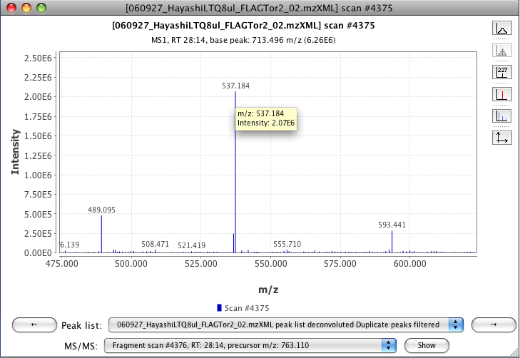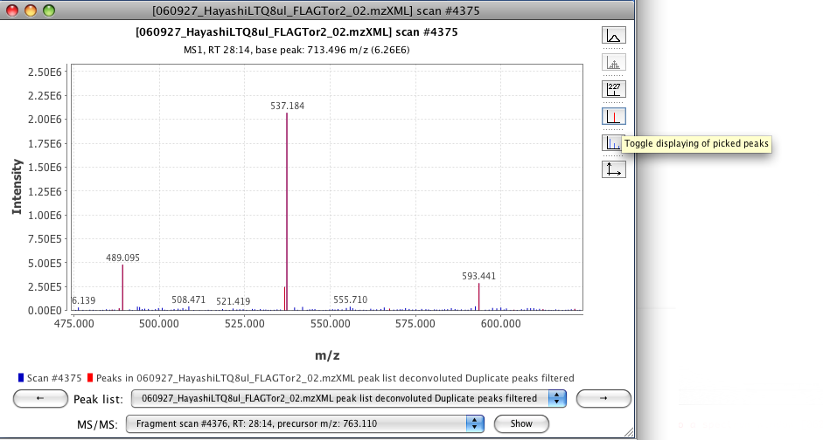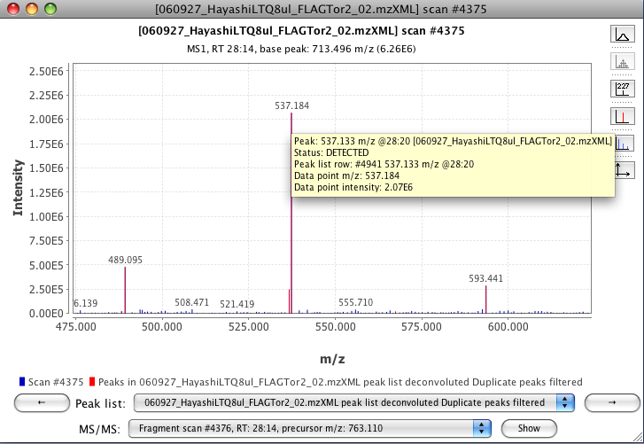

If a search of isotopes was done, is possible to visualize the predicted isotope pattern. The visualization of this pattern appears in color light green and can be toggle on/off.

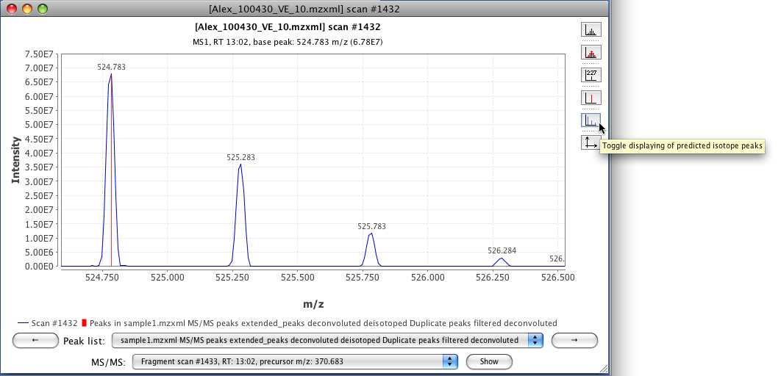

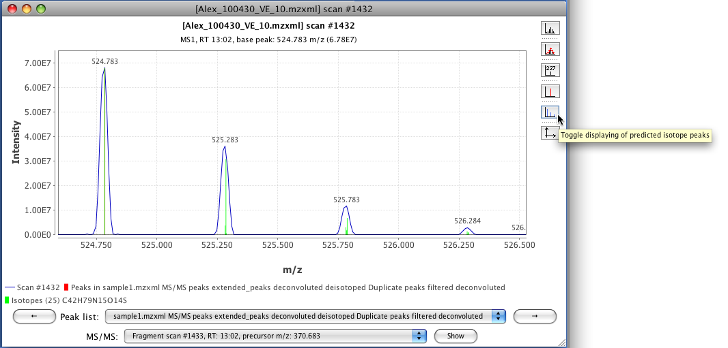

The last button of the toolbar display a pop-menu which allows to set the range in both axis.

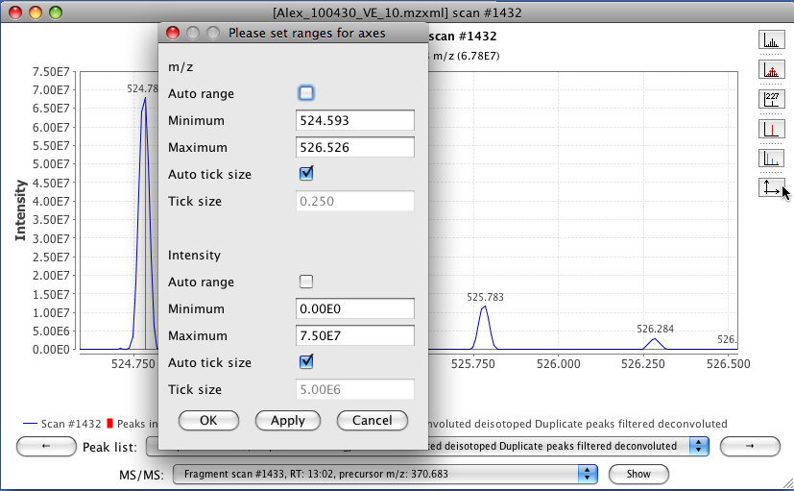

The bottom part of the Spectra plot contains information about the origin of the data (color + legend), peak lists where some of the peaks contain this spectrum, list of scans derived from an ion on this scan (fragmentation scans). There are two buttons with an arrow symbol, which allows the user to display to the next scan on time.

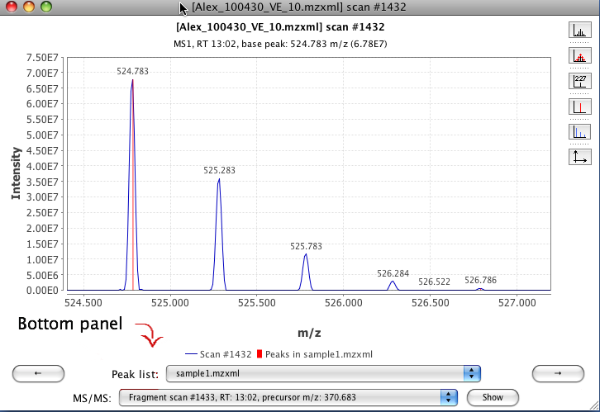

## 2D visualizer

This tool displays a plot of two dimensions, where X axis corresponds to retention time and Y axis is the m/z value. This visualization of spots in the plot corresponds with the intensity of the data in that region.

Generally this plot is well used in MZmine to display chromatographic peaks.

#### Parameters

MS level

MS level of plotted scans.

MS level

This refers to the level (MS1,MS2,... ,MSn) of the scans to be used.

Retention time

Retention time (X axis) range.

m/z range

Range of m/z values. If this range does not include the whole scan m/z range, the resulting visualizer is XIC type.

Additionally in the parameters window, the button "Set automatically" allows the user to set all the ranges automatically. MZmine will use the maximum ranges allowed by the raw data.

#### Functionality

This plot is using the third part library JfreeChart for its basic functionality. To zoom in, drag the mouse from left to right, selecting the area to zoom. To zoom out drag the zoom from right to left.

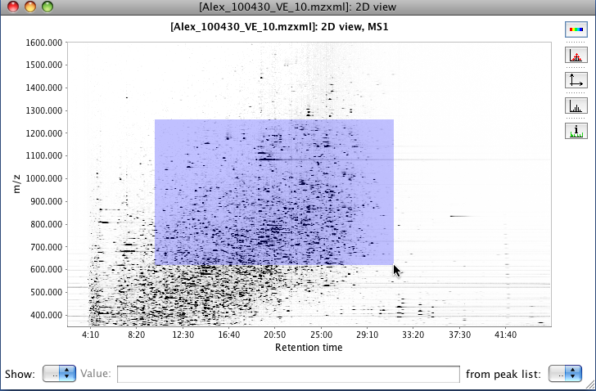

The intensity of the plot can be manipulated by the button "Switch palette". The intensity will increase with every click until the chart changes to red color. The intensity of the signal is displayed by difference in color or gray scale.

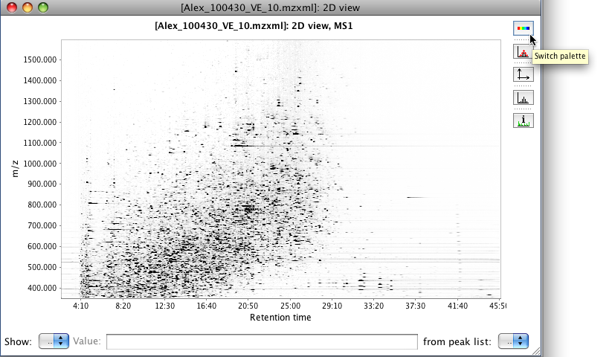

To display the data points used to from a spot or an identified peak, toggle the button "Toggle displaying of datapoints in continuous mode".

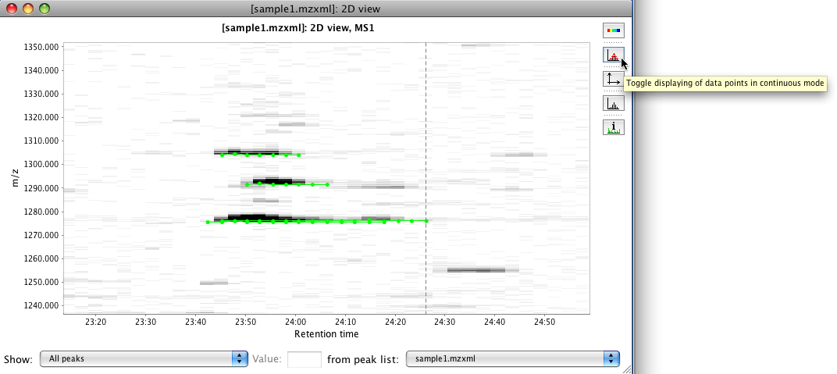

To adjust the range of the plot use the button "Setup range for axes". After click a pop-up window will appear with text fields where the user can adjust the ranges in both axis or set to automatic range.

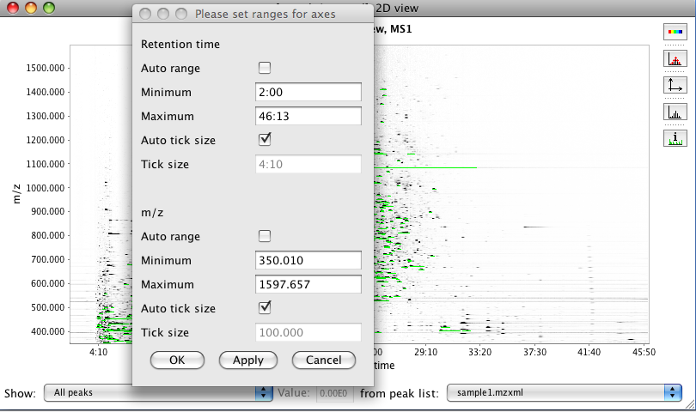

The button "Switch between continuous and centroid mode" changes the visualization of the data. If the color palette was selected is easier to notice the change. This option depends on the orginal raw data format.

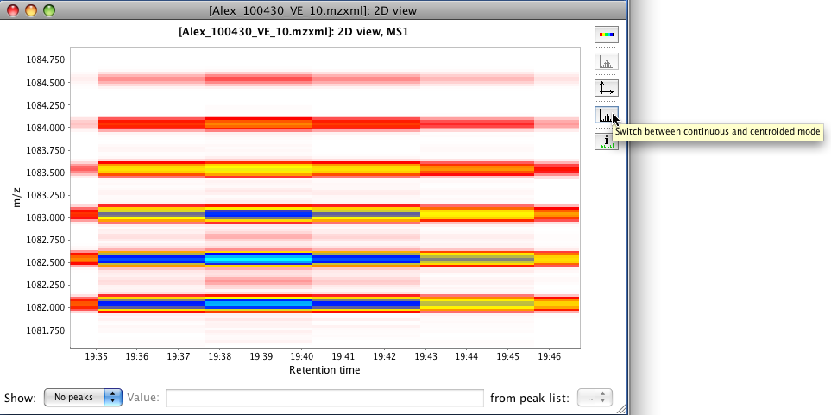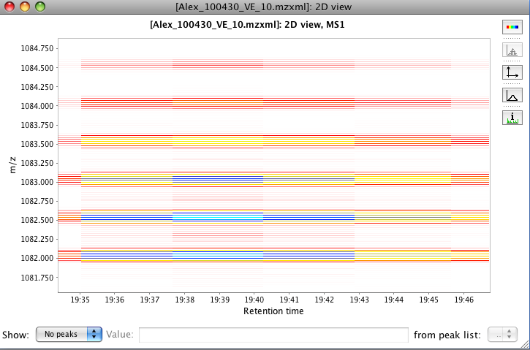

The tooltip that appears when the mouse is over each spot can contain information of the identified peak in that region. The related peak information can be omitted by using the button "Toggle displaying of tool tips on the peaks".

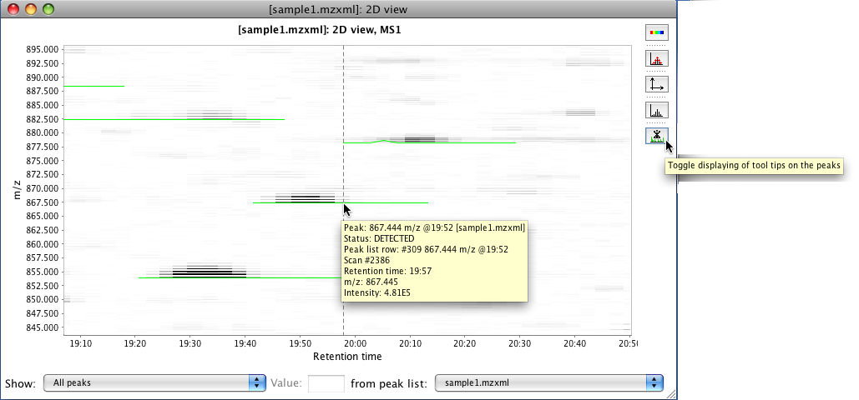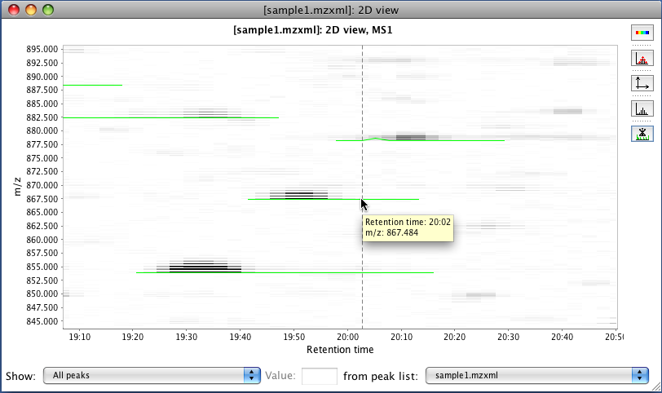

At the bottom of the panel the user can select the list of peaks to display in the plot (right combo box). This feature depends on the peak list associated to the visualized raw data in the current project. Also, the user can filter the number of displayed peaks by a threshold value or by number of most intense peaks.

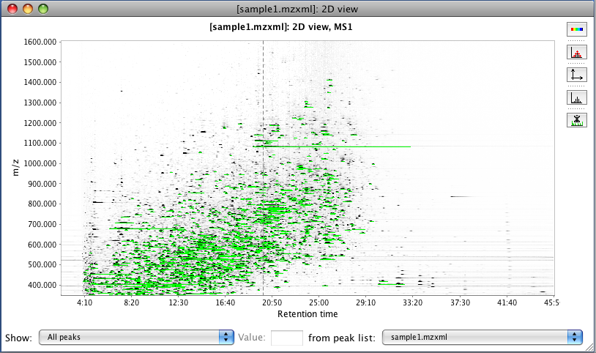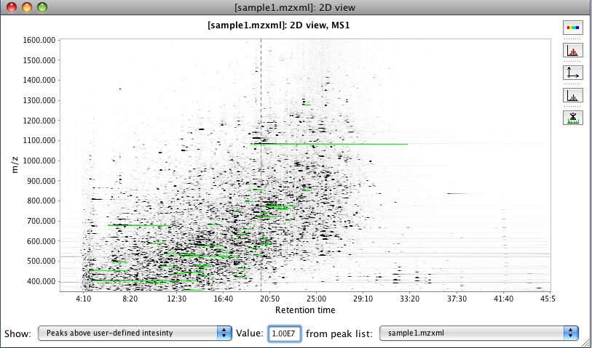

## 3D visualizer

This tool presents a three dimensional plot where X axis represents the retention time, Y axis the m/z value and Z axis the intensity of the signal. This plot is the collection of all the information from the raw data in a graphical representation.

#### Parameters

MS level

This refers to the scan level (MS1,MS2,... ,MSn) to be used to display the chromatogram.

Retention time

Retention time (X axis) range.

Retention time resolution

Number of data points on retention time axis.

m/z range

Range of m/z values.

m/z resolution

Number of data points on m/z axis.

Additionally in the parameters window, the button "Set automatically" allows the user to set all the ranges automatically. MZmine will use the maximum ranges allowed by the raw data.

#### Functionality

This plot is using the third part library JfreeChart for its basic functionality. To zoom in and out, use the third button functionality of the mouse. Also by click left button and dragging the mouse, the user can "rotate" the plot in any direction. If right button is used instead, the user can "move" the plot to any position.

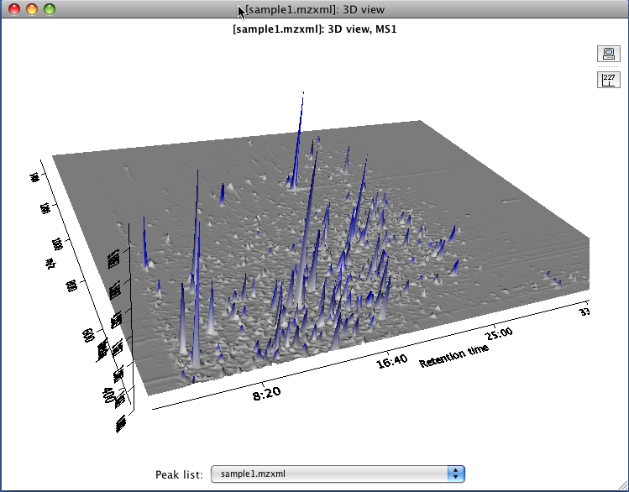

The toolbar contains two buttons, "Set properties" and "Toggle displaying peaks values". The first one open a pop-up window where the user can define the rage color depending the intensity and other characteristics of the plot. This properties depend on the JFreeChart library.

The button for displaying peaks values turn on/off the labels of the peaks. If a peak list is associated with the visualized raw data in the current project, the label of each peak could be the identity of the peak or the representative mass (m/z) of the peak.

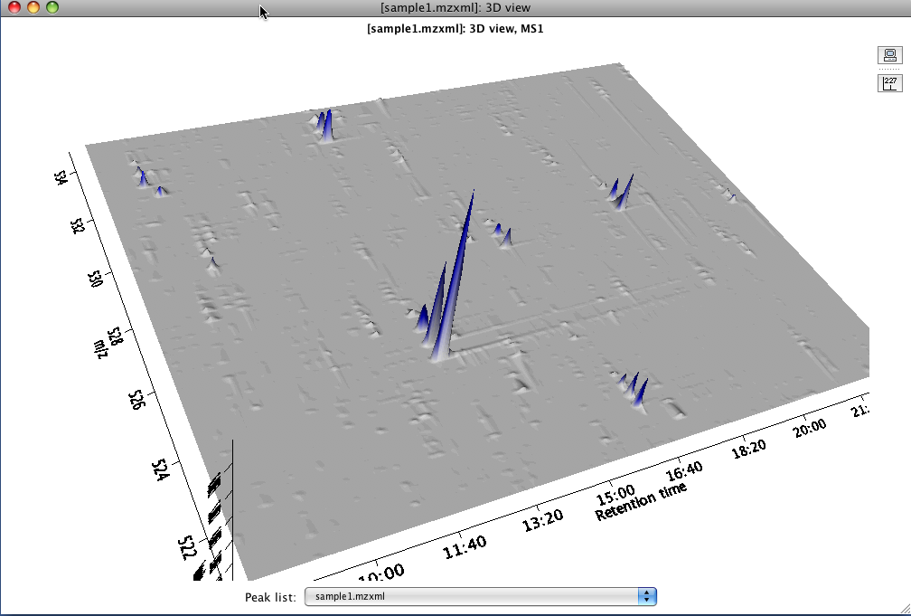

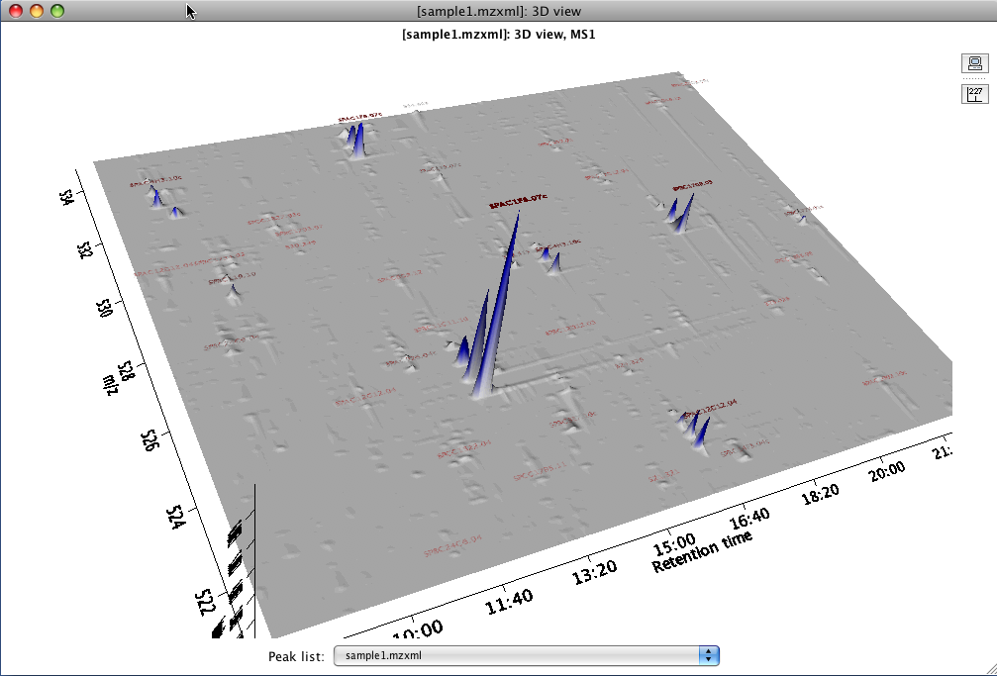

This plot also display the region where the peak was identified. By making Shift + right click over the label of the peak the user can observe a red cube which represents the space that covers the selected peak in terms of retention time, m/z, intensity.

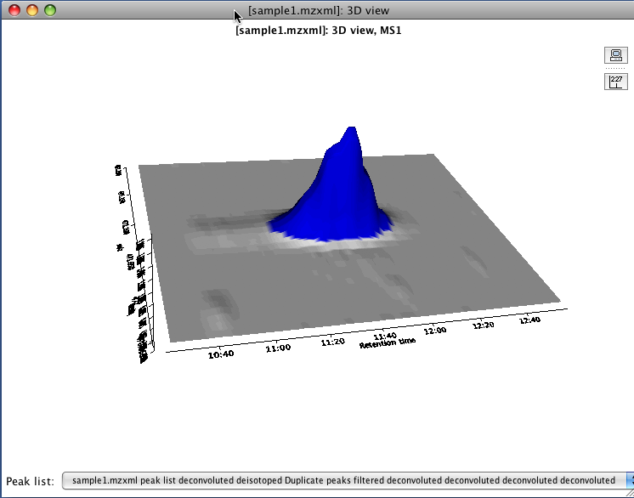

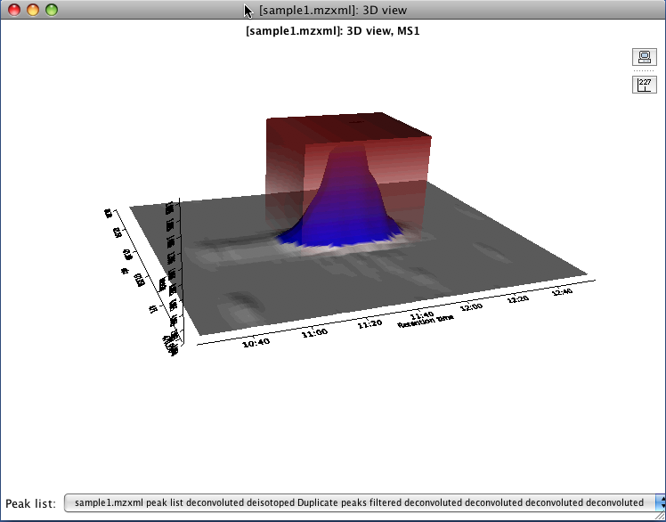

At the bottom of the 3D window there is a combo box where the user can select any peak list associated with the displayed raw data. If the user selects a different one than the current, the plot automatically changes the displayed labels of the peaks, according with the selected peak list identifications.

## Peak list table

This shows a list of identified peaks, after applying a series of methods to a raw data. This feature is one of the most important of MZmine project, because collect the result of many other modules.

The table is divided in many columns, which the user can edit which columns to show in the peak list. The columns can be divided into two groups "Common" and "Data file". The first group shows a collective information that represents the peak row. The second group displays the information of each particular peak in the row.

#### Common columns

ID

This is the number that identify the peak list row. A peak list row can contain one or many peaks that share the same mass range and retention time range but coming from different raw data.

m/z

This is the representative m/z value for this row peak (average of all peaks's m/z value). The m/z value of each peak depends on the peak identification method. Please refer to "Peak detection -" section of this help

Ret.time

This is the representative retention time value for this row peak (average of all peaks's ret. time value). The ret. time value of each peak depends on the used peak identification method. Please refer to "Peak detection -" section of this help

Identity

This is the name, assigned from the peak's identity. This value depends on the method to identify the peak. Please refer to "Identification -" section of this help.

Comment

This is an user input value. It can be edited by making double click.

Peak shape

This is graphic representation of the peaks in two axis (X - retention time, Y-intensity) with a different color for each peak in the row. The size of this graphic can be edited.

#### Data file columns

Status

A circle of different color will appear indicating the status of the peak. The meaning of the color is as follow, RED = no detected, ORANGE= manually detected by the user, YELLOW = detected by the "Gap Filler" tool and GREEN = detected.

Peak shape

TThis is graphic representation of the peaks in two axis (X - retention time, Y-intensity), in this case a XIC

m/z

The m/z value of the peak and depends on the peak identification method. Please refer to "Peak detection -" section of this help.

Ret.time

The ret. time value of the peak and depends on the used peak identification method. Please refer to "Peak detection -" section of this help

Duration

The duration of the peak on terms of time.

Height

The intensity of the peak in his highest point.

Area

The calculated area of the peak using the intensity and the duration of the peak.

Charge

The value of the ion charge. This value is obtained from the raw data or by the Isotope grouper module

#### Functionality

This table offers the possibility to sort the rows by some of the columns by making click on the header of each column.

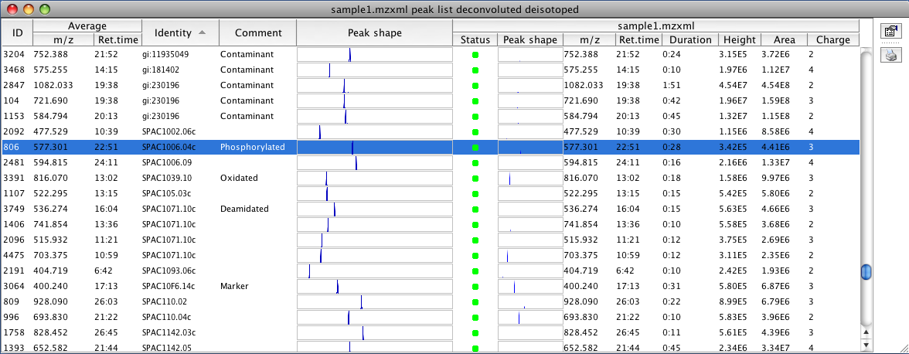

The tool bar at the right side of the table the user can edit the columns to display on the table and to print the displayed information.

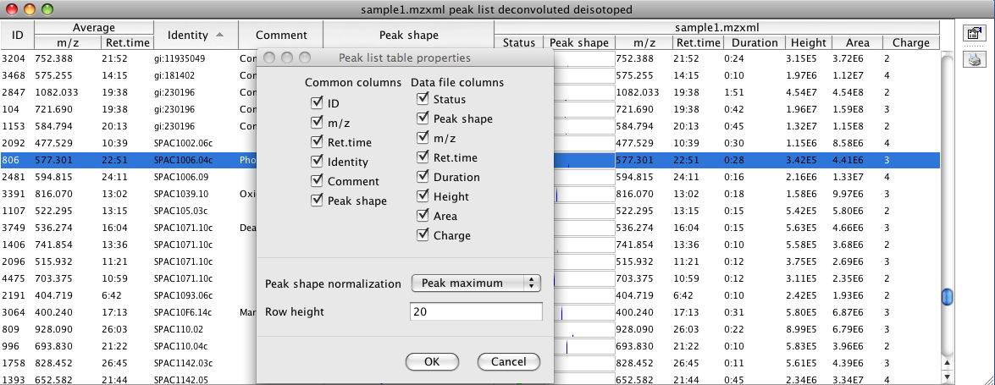

Each column has his a tool tip that provides some extra information. The contents of the tool tip box in the column identity depends on the applied method to identified the peak. Please refer to the "Identification" section of this help. This tool tip appears automatically when passing over the mouse.

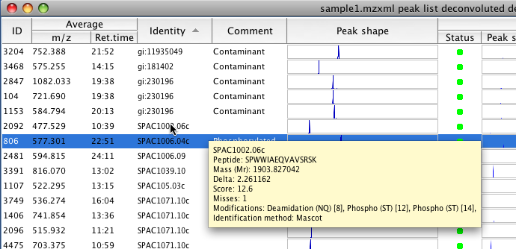

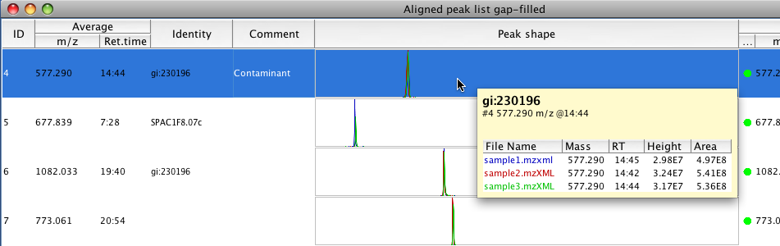

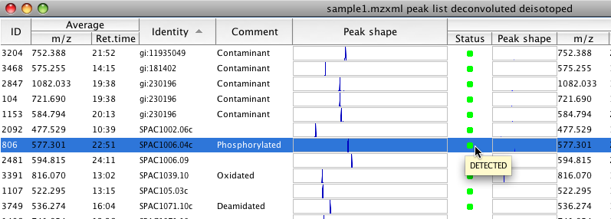

#### Submenu

A pop-up menu will appear if right click is done. Some of the options in this menu are active depending on the position (column) where the click is done and the number of selected rows.

Show

Under this option appear other submenu from where the user can choose the any visualization plot available for this peak. Some of the options depends on the characteristics of the selected row or peak. For more information about each kind of visualization refer to the "Visualization -" section of this help.

Search

This option is described in the section "Identification - Online database search" section of this help.

Plot using Intensity Plot module

An intensity plot will be formed using the selected peaks. Pleaase refer to "Visualization - Intensity plot" section of this help.

Manually define peak

The user can define manually the range of m/z and retention time of a peak. MZmine will create a new one or modify an existing peak.

Delete selected rows

The selected rows will be removed from the peak list. There is no way to recover the deleted rows.

Add new row

The same functionality as Manually define peak, but applied to all the raw data files in the peak list. At the end, the result is a new row with peaks from all the raw data files using the input ranges by the user..

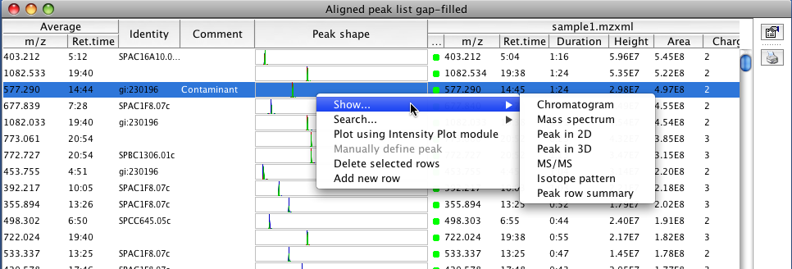

For the Identity column, a specific submenu will appear with left click. This submenu has the options to choose or edit the active identity from many associated to the same peak,

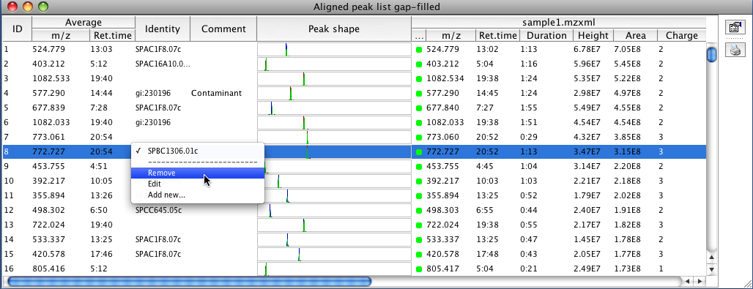

## Scatter plot

This tool shows a scatter plot with data from identified peaks in at least two or more data files.

#### Functionality

This plot is using the third part library JfreeChart for its basic functionality. To zoom in, drag the mouse from left to right, selecting the area to zoom. To zoom out drag the zoom from right to left.

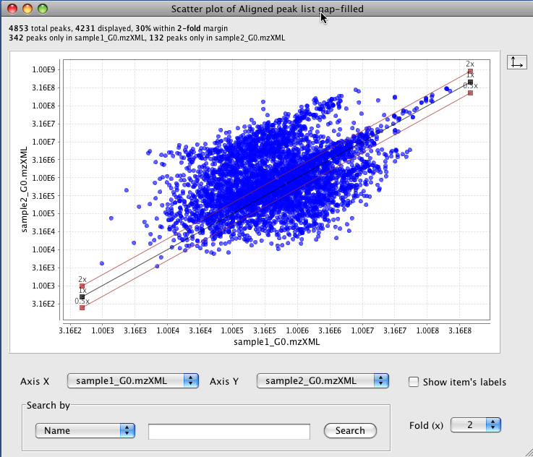

At the top of the window appears information about the number of displayed peaks (found information in the two selected peak lists). At the bottom of the window, there are combo box where the user can choose two peak lists to compare, one per axis.

The tool tip shows the chromatographic information of the peak from all the raw data files in the peak list. the user can use the right click menu and select the option "Show chromatogram" to display a TIC plot of the selected peak. Please refer to "Visualization - TIC plot" section of this help.

A search for a peak can be done using three options (name, retention time and m/z value). There is a check box to switch on/off display labels from matched peaks to the search parameter.

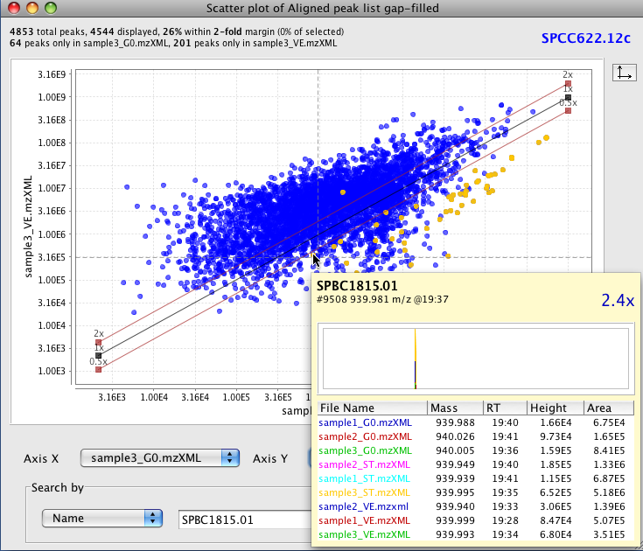

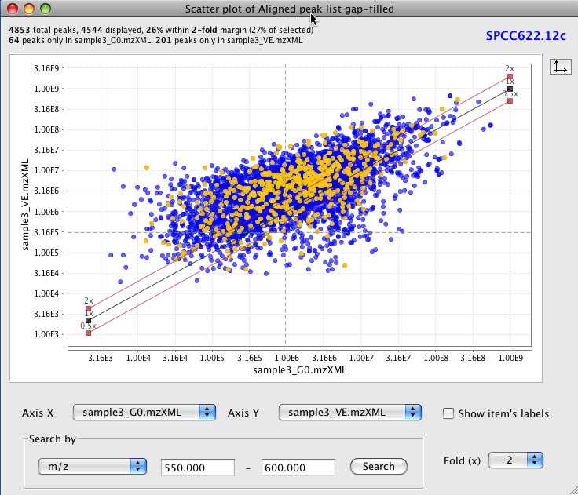

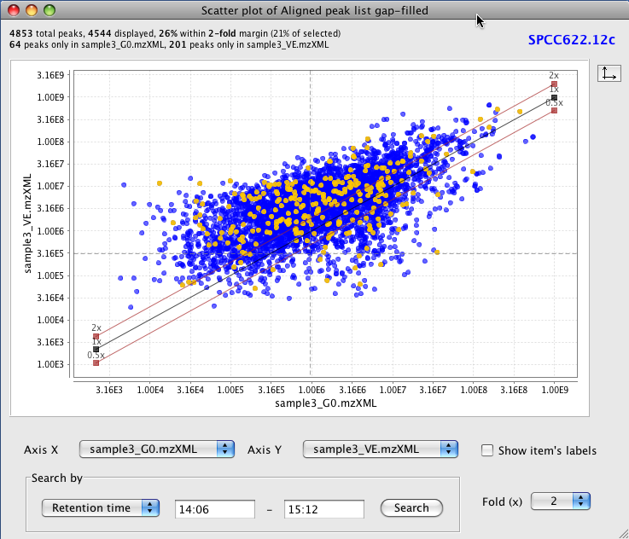

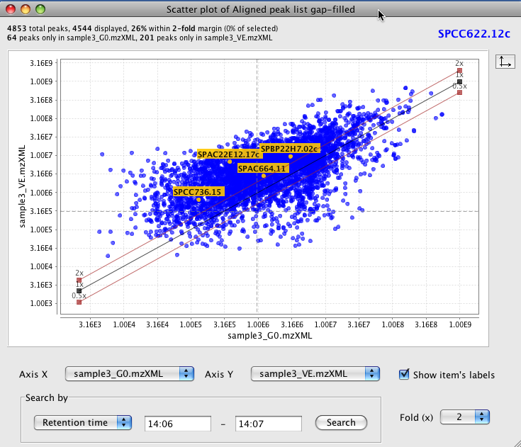

## Histogram plot

This plot displays a graphic representation of frequencies. Each rectangle represents an interval of frequency. The height is also equal to the frequency density in that interval. The total area of the histogram is equal to the number of data. This tool can use the m/z value, height, area or retention time as frequency value (X axis) and number of peaks in each interval (Y axis).

#### Parameters

Raw data files

Column of peaks to be plotted.

Plotted data type

Peak's data to be plotted ( m/z value, height, area or retention time)

Plotted data range

Range of data to be plotted. This range is automatically loaded with max values from the raw data.

Number of bins

The plot is divides into this number of bins.

#### Functionality

This plot is using the third part library JfreeChart for its basic functionality.

To zoom in, drag the mouse from left to right, selecting the area to zoom. To zoom out drag the zoom from right to left.

The next figure shows a histogram using the retention time value. This data is coming from a raw data with a duration of 60 min. Most of the peaks appears around 17 min.

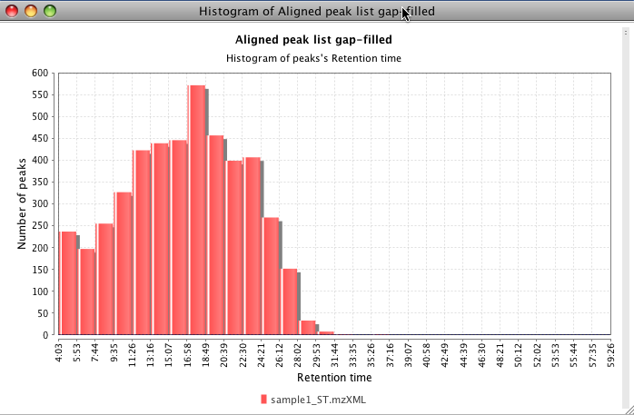

The next figure shows a histogram using the m/z value. This data is coming from a raw data with a range from 350 to 1400 m/z.

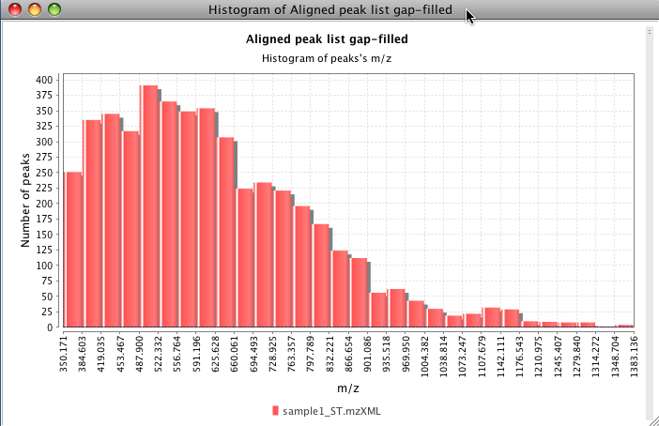

## Intensity plot

#### Parameters

Data files

Selects the raw data files from where the peaks were detected

X axis value

X axis display the raw data file name or the parameter defined in the "set sample parameters" window

X axis value

The user can choose from peak's height, area or retention time value to display in this axis.

Peaks

The user can select the peaks to use in this plot.

#### Functionality

This plot is using the third part library JfreeChart for its basic functionality. To zoom in, drag the mouse from left to right, selecting the area to zoom. To zoom out drag the zoom from right to left.

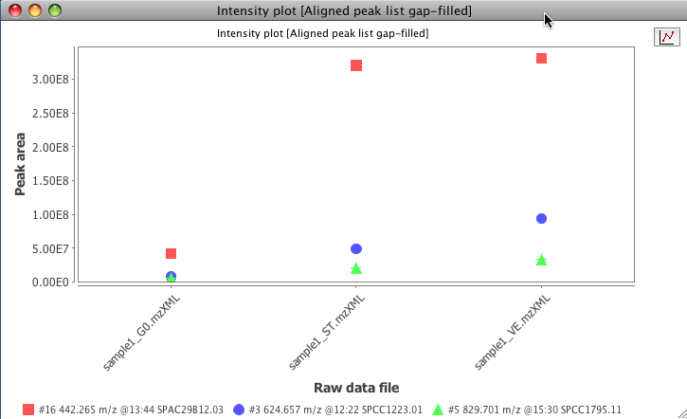

A tool bar on the right side of the window has a button to switch off/on the display of lines to connect the points.

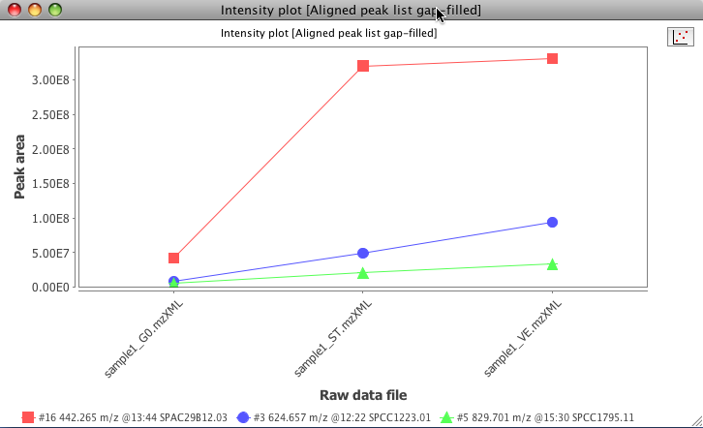

Optionally an error bar can be displayed indicating the standard deviation of the peak value in many samples. In order to display this bar, the raw data files need to be grouped. This functionality is done by setting sample parameters defined by the user.

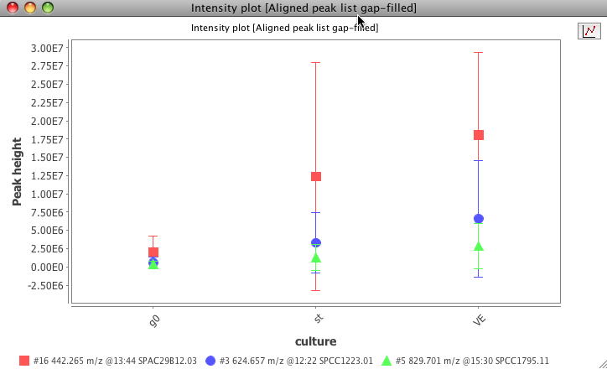

## Neutral loss visualizer

This plot shows the neutral loss calculated from all MS2... MSn in the selected raw data file. The user can define the number of most intense fragments to use in the calculation of the neutral loss. If a recurrent neutral loss occurs, a line pattern in the plot can be observed.

#### Parameters

X axis

X axis type. The user can choose from "Retention time" or "Precursor mass"

Retention time

Retention time (X axis) range.

Precursor m/z

Range of precursor m/z values.

Fragments

Number of most intense fragments to check for neutral loss.

#### Functionality

This plot is using the third part library JFreeChart for its basic functionality. To zoom in, drag the mouse from left to right, selecting the area to zoom. To zoom out drag the zoom from right to left.

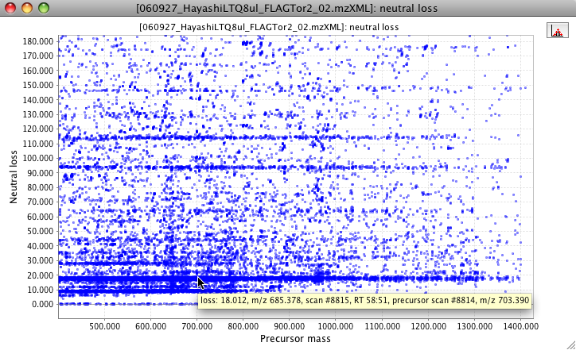

The user can highlight spots in a range of m/z. This range can be for neutral loss or for the parent ion mass. This option appears in a submenu by making right click on the plot area.

